Yellow Candle Home Ceremony
Wednesday, 27th April 2021

Lighting a Yellow Candle on Yom HaShoah provides a unique opportunity to start a conversation about the Holocaust within the safe space of the home. Take this opportunity to engage as a family, explore the themes of Remembrance and Dedication to further your understanding of our Jewish history.
The ceremony ideas that you will find below are purely suggestions. Given the sensitivity of the subject, we would like to recommend that families make a conscientious choice regarding who participates in the ceremony and when the Yellow Candle is lit. Some preparation is advised for parents who wish to engage their children in the home ceremony.

A broad range of age-appropriate resources that can be used for the Yellow Candle home ceremony are available on
www.yellowcandleuk.org/educationalresources

Below are a number of activities that can accompany the lighting of your Yellow Candle and marking Yom HaShoah in your homes.

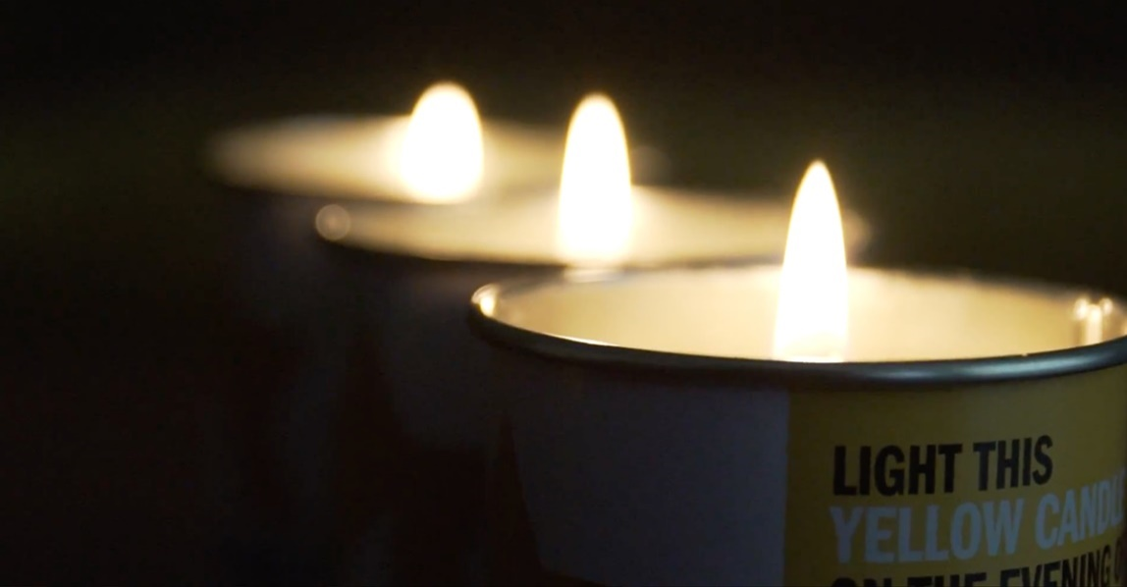

Families with Children under the age of 8

Try to designate a time when the whole family can come together and allocate 10-20 minutes. The emphasis on this ceremony is about commemoration and celebration. Since our homes are the centres of our world, we should acknowledge that it is a place where we can come together just as in other celebrations or events.

Preparation

Parents should take some time to explore the resources available on https://www.yellowcandleuk.org/parents before the home ceremony, think about their own family history and personal connections to the Holocaust.

This home ceremony will focus on commemoration; explain to your children that every event in the Jewish calendar commemorates something that happened in the past, sometimes a very long time ago and other times more recently. The story of Pesach, told in the Haggada during the Pesach Seder is a great example of this.

Yom HaShoah is a day when we remember a sad event in our recent history, when our Grandparents or Great-Grandparents were alive – as was the Queen.

Dedication

You may choose to light a Yellow Candle and place the card with the name victim next to it as a way to remember a person who is no longer with us.

Since candles are used in many occasions in Judaism, parents of younger families can also refer to the use of candles to mark special occasions such as at the beginning of Shabbat or Chaggim, when Shabbat ends.

Learning

At this age children needn’t learn about the Holocaust in itself; explore the resources on the website; if you want, listen to the story of ‘Wilfrid Gordon McDonald Partridge’ and have a conversation about your family, about memory and about the importance of commemorating events in our Jewish history like we do during the Pesach Seder.

You can conclude the home ceremony by posting an image of your lit Yellow Candle on social media, tagging @yellowcandleuk and #Yellowcandle helping us create the largest Communal Holocaust memorial on the eve of Yom HaShoah

Families with Children over the age of 8

Try to designate a time when the whole family can come together and allocate 10-20 minutes. The emphasis on this ceremony is about commemoration, dedication and learning.

Preparation

Parents should take some time to explore the resources available on https://www.yellowcandleuk.org/parents before the home ceremony, think about their own family history and personal connections to the Holocaust.

Place your yellow candles and names on the table with the name card face down. Start by discussing why we have days of remembrance in the calendar. What kinds of happy and sad things do we remember and why?

Explain that Yom HaShoah is the Jewish day of remembrance for people who died in the Shoah, the Holocaust. Traditionally memorial candles are lit in Jewish homes and in Israel, an alarm is sounded and everyone stops where they are for 2 minutes of silent thought. This might be the appropriate time to place the name cards next to the candles on a shelf or windowsill. You might start or end with lighting them and perhaps play or watch the siren in Israel. https://www.youtube.com/watch?v=TYeOEAsHS78.

Dedication

You may choose to light a Yellow Candle and place the card with the name victim next to it as a way to remember a person who is no longer with us.

Each candle is dedicated to an individual; you can research the story behind the name by visiting the Yad Vashem archives and take some time to discuss and explore the life they may have had. Have a discussion dedicated to the child or person that never grew up. How is my childhood like theirs? Remembering the things that they would have done, played with etc

Learning

At this age children can begin to explore some of the themes around the Holocaust; from the story of Anne Frank, to ‘What makes a hero’, to ‘the Journey’ an interactive story of a Jewish refugee on the Kindertransport. All these can be found on www.yellowcandleuk.org/ks2

To bring the Tekes to a close, it might be a good opportunity to then focus on your family being together for celebration and special occasions. This video could be used https://www.youtube.com/watch?v=Vuh1-jDi7Qw

You can conclude the home ceremony by posting an image of your lit Yellow Candle on social media, tagging @yellowcandleuk and #Yellowcandle helping us create the largest Communal Holocaust memorial on the eve of Yom HaShoah

Families with older children

Try to designate a time when the whole family can come together. Depending on the age of the children, this home ceremony can be led by the adults or the young people themselves, although this will require a little preparation. The emphasis on this ceremony is about dedication and empowerment.

Preparation

We believe it is important to create a personal connection with the commemoration of Yom HaShoah; whilst the events of the Holocaust have taken place within the living memory of our Grandparents or Great-grandparents, young people may struggle to connect with the events and effects that the Holocaust has had on the Jewish Community worldwide.

As such, it is important to explore some of the resources available on www.yellowcandleuk.org/ks4 and discuss some of your family history and personal connections to the Holocaust.

Dedication

You may choose to light a Yellow Candle and place the card with the name victim next to it, as a way to remember a person who is no longer with us.

The Yad Vashem archives hold the names of over 4.5 of the 6 million Jews murdered by the Nazis and their accomplices during the Holocaust; most of these names do not have a story accompanying them, they are written on a short form in Hebrew, English or any of the other languages spoken by European Jewry. They are written by a family member, neighbour or friend who survived the Holocaust and made their mission to remember those that perished.

The names of nearly one and a half million victims remain unknown. It is our collective moral imperative to persist in our efforts to recover their names and restore their identities.

The Yellow Candle Project is meant to assist Jewish people to remember the names of those who perished; anyone who wishes to, can find the record for their Memorial Candle name on the Yad Vashem archives.

Learning

Explore the Yellow Candle website, learn about the history of the Holocaust through the life of Anne Frank or the experiences of our Holocaust Survivors, take action to ensure the memory of those who we lost is never forgotten. All the resources can be found on www.yellowcandleuk.org/ks4

You can conclude the home ceremony by posting an image of your lit Yellow Candle on social media, tagging @yellowcandleuk and #Yellowcandle helping us create the largest Communal Holocaust memorial on the eve of Yom HaShoah

