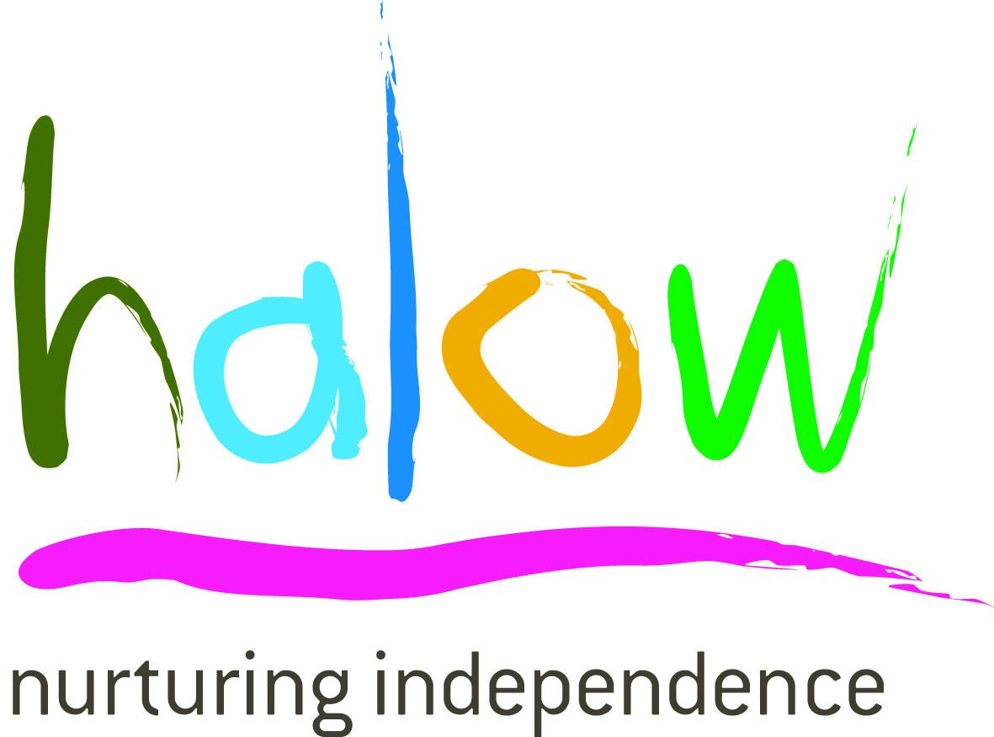

PRESS RELEASE
DAMON HILL OBE LEADS RIDERS HOME FOR CHARITY
Event raises over £76,000

Tuesday 6th May 2014, Former World Motor Racing champion, Damon Hill OBE, returned home to Guildford on Sunday 4th May 2014, with over 80 other riders after cycling 250 miles.
Damon, who is Patron of the halow project, and fellow riders, raised £76,274 for the charity by cycling 250 miles from London to Guildford via France!
The oversubscribed ride, now in its third year, left Putney in southwest London for France on Friday 2nd May 2014. On a route that took in some of the most picturesque countryside in the UK and France, riders endured three days of intense riding in order to meet the gruelling schedule ahead of them.
Damon Hill OBE commented: ”This was an extremely gruelling ride against a strong headwind, particularly tough over the French hills but as one rider said this is nothing to the mountains our young people have to climb every day.
“ We have been truly overwhelmed with the enthusiasm and commitment we’ve had from riders and supporters. Huge thanks to all those who took part in the ride and everyone who helped make it such a success.”
halow project Director, Yvonne Hignell added: ”I am delighted to see this event has gone from strength to strength. Thanks to our generous sponsors, every penny raised will go straight towards our services for young people.
“This amount of money will make a significant difference to the lives of young people with a learning disability. It is not too late to make a donation, if anyone can help, please visit: http://uk.virginmoneygiving.com/damonhill - being a small charity with no state funding - every little truly does help."
The halow project is a Guildford-based charity committed to supporting young people with a learning disability to have the same life choices and chances as any other young person. From its community based social activities and learning programmes, to its 1:1 personalised support via its Buddy Service, halow helps young people to gain confidence, skills and be supported to live as independently as possible.
/More...
If you would like to make a donation, refer a young person or require further information, please visit: www.halowproject.org.uk or call 01483 447960.
-ENDS-
Press Contact: Richard Nelson richard.n@halowproject.org.uk or Tel: 01483 447960
NOTES TO EDITORS:
- The inspiration for the halow project came from Harriet, Amber, Laura, Oliver and William, each of whom has a learning disability. Their parents, all friends were concerned with the prospect of their children’s future and others like them. As a result, halow was formed in 2006 and has been working successfully with other organisations across Surrey.
- halow is a young, vibrant, organisation that works with young people aged 16-35 with a learning disability, communication difficulty or special need with varying degrees of severity. halow is passionate that the people it supports have the right to expect the same life experiences and opportunities as any other young person.
- halow’s patron is Damon Hill OBE. Registered charity number 1116773
- halow is always used in bold and lower case.

The event was organised by 2Boats, a small but rapidly growing cycling events company. 2Boats organises personal, well planned sportives, audaxes and multi day charity rides, and offer full support in training and sponsorship guidelines. www.2boats.org
Sponsors for 2014 include:
Headline sponsor of the event is Young’s, based in Wandsworth; SW London Young’s is the UK’s oldest brewery and prides itself on offering a wide range of venues for all tastes. From country and family orientated eating and drinking, to stylish City bars, there is something for everyone. www.youngs.co.uk

The Arrow Shipping Group: established in 1990, the Arrow Ship broking Group's international team of brokers is at the forefront of change in the marine transportation sector. Pioneers in the Chinese shipping market, its reach is global; encompassing offices in London, Hong Kong, Shanghai, Monaco, Copenhagen, Athens and Singapore. www.arrowship.com

GM Recruitment George Willis and Mark Foxwell formed GM Recruitment back in early 2004. From backgrounds in both recruitment and contracting, George and Mark wanted to deliver a high quality, good value recruitment solution for clients working in the construction and related industries. www.gmrecruitment.co.uk

The Devonport Inn on the Cleave has a unique position in this historic, charming and traffic free Cornish village yards from the small beach that looks out across the Rame peninsula. www.devonportinn.com

Ref: halowPOST250APP

