The
Disability
Standard
2005

Benchmark

Report

R & D Group

- Abbey • BT • BUPA • Barclays • Cable & Wireless
- Centrica • HSBC • PricewaterhouseCoopers • Royal Mail
- UnumProvident • Department for Work and Pensions
- Department for Education and Skills • Jobcentre Plus
- Metropolitan Police Service • Office of the Deputy Prime Minister
Launch Media Partner - Financial Times Group

The Disability Standard 2005
Participating organisations

Alliance & Leicester
Aviva
B&Q
Barclays
BBC
BT
BUPA
Camelot Group
Centrica
Cisco Systems
Deloitte & Touche
EDS
Employers' Forum on Disability
First Rate Travel Services
Goldman Sachs International
HBOS
HSBC
InterContinental Hotels Group
ITV
Jobsgopublic
KPMG
Land Securities Group
Lehman Brothers
Lloyds TSB
McDonald's Restaurants
Merrill Lynch UK
Microsoft UK
Motability Operations
Nationwide Building Society
Pfizer
Reed in Partnership
Royal Bank of Scotland
Royal Mail
Sainsbury's Supermarkets
Scottish Power
The Financial Times
UnumProvident
West Midlands Co-operative Society
Total UK
Adult Learning Inspectorate
Appeals Service
Arts Council England
British Council
British Transport Police
Camden and Islington Primary Care Trust
Child Support Agency
City of London Police
Department for Culture, Media and Sport
Department for Education and Skills
Department for Transport
Department for Work and Pensions
Department of Trade and Industry
Disability and Carers Service
Disability Rights Commission
Driving Standards Agency
Dstl
Foreign and Commonwealth Office
Hertfordshire Constabulary
Highways Agency
HM Land Registry
HM Revenue & Customs
HM Treasury
Jobcentre Plus
Learning and Skills Council
Leeds Metropolitan University
Leicestershire Constabulary
London Borough of Camden
London Borough of Tower Hamlets
Lothian and Borders Police
National Assembly for Wales
Northamptonshire Police
Office of Fair Trading
The Corporate Centre
The Patent Office
The Pension Service
Valuation Office Agency
Victoria & Albert Museum
West Midlands Police
The Rent Service
UK Passport Service
Employers’ Forum on Disability

Contents

Introduction

What is the Disability Standard?
Summary
Designing the Disability Standard

Overall results What have we learnt?

Motivate
Results highlights
Detailed results
Good practice examples

Act
Results highlights
Detailed results
Good practice examples

Impact
Results highlights
Detailed results
Good practice examples

When diversity isn’t…

Disability is not on the diversity radar screen

Public and private sectors compared

Results highlights

Motivate
Breakdown of results

Act
Breakdown of results

Impact
Breakdown of results

Contents

Conclusions and recommendations

Conclusions

Recommendations

Glossary, appendices and acknowledgments

Glossary

Appendix 1
Who responded to the Benchmark?

Appendix 2
Benchmarking results

Appendix 3
How the scores were calculated

Acknowledgments

Employers' Forum on Disability

The Employers' Forum on Disability is the world's leading employers' organisation focused on making it easier for organisations to become disability confident. We have over 400 members who between them employ nearly a quarter of the UK workforce.

The Employers' Forum is distinctive in that it is a business led, membership organisation working for the mutual benefit of business and people with disabilities. Our work is firmly based in the business, economic and ethical case for positioning disability as a business and societal priority.

© This publication and the information contained therein, are subject to copyright and remain the property of the Employers’ Forum on Disability. They are for reference only and must not be reproduced, copied or distributed without prior permission.

Introduction

What is the Disability Standard?

Summary

Designing the Disability Standard

What is the Disability Standard?

For the first time ever, pioneering British employers have come together to look at how well they are doing on disability, and to learn from each other about what they could be doing better.

The Disability Standard incorporates the world's first detailed Benchmark Survey measuring organisations' performance on disability. This year, 80 UK employers - with a combined workforce of nearly two million employees - have used the Standard to examine their performance on every aspect of disability as it affects their business.

Employers are aiming to become more 'disability confident'. A truly 'disability confident' organisation would reach the Standard by scoring 100% on the Survey.

The Disability Standard provides the first measure of the extent to which the participants have the commitment, the leadership and the policies and procedures they need if they are to employ and serve disabled people efficiently and mainstream disability confidence into the workplace.

The Disability Standard, a comprehensive management tool, comprises:

• A self-completed Benchmark Survey, which requires the organisation to provide evidence to justify its ratings. The Survey is independently validated and addresses all aspects of policies and procedures relating to employment, customer care, IT, the built environment, new product development, e-commerce and e-recruitment, corporate responsibility, procurement, health and safety, occupational health, marketing and communications, consultations with disabled stakeholders and staff, management training, and top team commitment.

• The Standard Directory, which links step-by-step to the Survey, lists all the relevant disability legislation, codes of practice, regulations, technical standards and best practice guidance from the Disability Rights Commission, the Forum and other recognised authorities.

• The Benchmark for Action Conference, at which overall results of the Survey and the key messages deduced from the results are fed back to the participating organisations. It is also an opportunity for organisations that took part to discuss their results with peers and share what works, what doesn't work, examples of best practice and barriers to improvement.

The Disability Standard encourages those promoting change to:

- Motivate the organisation and its people to move into action
- Act to develop and value diversity across all areas of business activity
- assess the Impact of diversity action and use the learning to re-motivate the organisation and set new goals.

Summary

The survey results provide a fascinating insight into the extent to which 80 diverse UK employers have become 'disability confident'.

The top performers have demonstrated they now manage disability as an integral part of the way they do business. Others are still putting the foundations of good practice in place. And some could well be at legal and reputational risk.

This year, the participants scored, on average, 57%. Only 18 organisations have scored above 75%, and of these, 11 were public sector organisations and just six were FTSE 100 companies.

What does 'disability confident' mean?

A 'disability confident' organisation will:

- naturally include disabled people as part of a truly diverse workforce
- view disabled customers as an important and increasingly significant market segment and disabled people, their friends, families and colleagues as important stakeholders
- see the old way of looking at disability - which often results in discrimination because assumptions are made regarding what disabled people can and cannot do - as no longer acceptable
- be skilled in making adjustments and be more responsive to the potential contribution of every employee
- focus on the capacity and potential of the individual and empower disabled individuals (and indeed everyone) to contribute by making reasonable adjustments and as a result gain genuine business benefit.

Organisations which have scored above 57% (the average) are all taking action to:

- establish policies to support disability in employment and product/service delivery
- put a team or individual in place to develop disability equality
- ensure adjustments are offered to every job applicant throughout recruitment and selection
- provide accessible training and development
- ensure non-discriminatory appraisal and promotion criteria
- provide accessible built environments to employees and customers
- retain employees who become disabled
- develop best practice absence and long-term sickness policies
- provide accessible information to every employee and customer
- consult with their disabled employees
- include disability in their social responsibility agenda.

The challenge for these organisations over the next year is to build on and to extend good practice. They need to ensure that commitment, responsibility and resources are focused on turning plans into actions and that they then assess the impact of what has been done.

For those 37 organisations scoring below the average of 57%, many have yet to position disability as a priority and have been unable to secure the resources and shared responsibility required to improve performance. Indeed, some will be at legal and reputational risk.

It is important to remember that this is a self-selecting group of public and private
sector employers that recognises the need to address disability, is now publicly
committed to self improvement, and has committed time and resources to this
demanding benchmarking process.

If such a group of employers still continues to confront such obstacles to best practice, then surely the learning from this survey will be of interest to a much wider employer community.

Designing the Disability Standard

Research and trials

The Disability Standard was developed by the Employers' Forum on Disability and Dr Gillian Shapiro. The Survey was researched and trialled in partnership with 15 of our leading members who made up the Research & Development (R&D) Group and with the Forum's distinguished disabled associates.

The Disability Standard R&D Group

Abbey; BT; BUPA; Barclays; Centrica; Cable & Wireless; HSBC; Royal Mail;
PricewaterhouseCoopers; UnumProvident;

Plus

The Office of the Deputy Prime Minister and the Metropolitan Police Service, who
joined Jobcentre Plus, the Department for Education and Skills and the Department for Work and Pensions in adapting the Standard to meet the needs of the public sector and the police service.

The Standard is underpinned by the Diversity Change Model© developed by Dr Shapiro from extensive research in the UK, Europe and in North America.

Overall results

What have we learnt?

Motivate
Results highlights
Detailed results
Good practice examples

Act
Results highlights
Detailed results
Good practice examples

Impact
Results highlights
Detailed results
Good practice examples

Motivate: Results highlights

The Motivate section of the Survey focuses on the commitment, policy and resources which must be in place, as a foundation, if an organisation is to move on to become disability confident.

The table below shows the overall average scores of all 80 participants for this section
 | Total %
Motivate section average | 61
Identify vision & goals | 61
Establish policies & standards | 66
Establish strategy links & a business & ethical case | 54
Establish management commitment & accountability | 60
Establish resources & a management structure | 61

Most benchmarking organisations:

- have a stated organisational commitment to becoming disability confident
- take responsibility for disability at the most senior management level
- are appointing individuals or teams to direct and develop progress on disability issues.

Benchmarking organisations show commitment to becoming disability confident...

- 79% report that there is a stated organisational commitment to disability and a further 21% are working on this.
- 70% have someone at Board level taking responsibility for disability equality and a further 21% are working towards this.
- 73% have an individual or team responsible for advising or leading on disability and a further 27% are working towards this.

...but the rationale for becoming disability confident is not clear to all

Although the results show a high level of stated commitment to disability, many
organisations have yet to establish a clear motivation for addressing disability as a priority.

- Only 46% of respondents have an effective business or ethical case for disability in their organisation - although a further 39% are working on this.

Note: The results show a slightly greater commitment to and focus on meeting disabled employee needs and aspirations over those of disabled customers.

- Only 38% have written policies setting out how disability equality will be achieved in service provision compared with 48% who set out how disability equality will be achieved in employment.
- Senior management in 69% of the 80 responding organisations have made a clear public commitment to valuing disabled people as employees but only 60% have made a public commitment to valuing disabled people as customers.

Results show that disability action plans, policies and budgets appear concentrated in HR and property services departments with much less evidence of action plans and standards being set to ensure the accessibility of products and services.

Most organisations would find they needed to engage departments other than HR and property were they to act on what they learn from consultations with disabled employees and customers.

- 36% or less set disability goals in departments outside human resources and property services.
- 26% of organisations use the results of consultation with disabled employees to help set disability goals and policies.
- 29% of organisations use the results of consultation with disabled customers to help set disability goals and policies.

And there is little sign of shared accountability and responsibility across departments

Only 14% of organisations effectively build responsibility for disability into managers' performance goals. A further 35% are working towards this but 51% have yet to position this as a priority.

Conclusions

Despite the clear commitment to disability, many benchmarking organisations will find it difficult to make further progress unless they get the motivation and accountability for disability right.

What the best do differently…

Respondents which have scored above 75% have all made a clear business and ethical case for disability in their organisations. They are working towards ensuring that disability is not just an HR issue but that the value to the organisation of meeting the needs and expectations of disabled customers and stakeholders as well as employees is well understood. They are also working towards ensuring that responsibility for becoming disability confident, to include action plans and accountability is shared by managers and departments across their organisations.

Priorities for action

1. Set disability goals with budgets in departments across your organisation.
2. Put written policies in place that set out how disability equality will be achieved in service provision and employment.
3. Build an economic/business and ethical case for disability in your organisation so that it is motivated for action beyond legal compliance.
4. Allocate responsibility for making progress towards becoming disability confident across all your managers.

Motivate: Detailed results

There is strong commitment to becoming disability confident

79% of respondents have a stated organisational commitment to disability.

Senior management in 69% of organisations has made a clear public commitment to valuing disabled people as employees. A Board member has responsibility for disability in 70% of the benchmarking organisations - although Boards in only 53% annually review progress on disability.

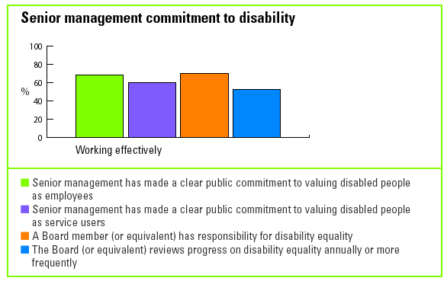

Crucial to getting it right

- 73% of respondents have an individual or team responsible for developing or advising on disability as part of the overall diversity agenda.
- The overall benchmark score of these organisations is 57% compared to 47% for those organisations which do not have them.
- Notably, every respondent to score more than 75% overall, has this in place.

Responsibility for disability is left to just a few

Despite a high level of senior management commitment to disability, little effort has yet been made to spread ownership and responsibility for progress more widely.

- Only 14% of respondents report that specific responsibility for disability is built into every manager's performance goals - 51% have yet to take any action on this.
- Only 10% include an evaluation of what managers have done to support the organisation's disability goals in appraisals - 56% have yet to take any action on this.

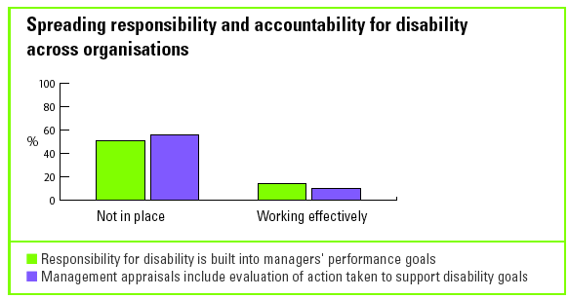

Moving from aspiration to action

Despite a strong commitment to becoming disability confident, many organisations have yet to translate their good intentions into action.

- 49% of respondents have set out a clear vision of what their organisation will be like when it has become disability confident and only 48% have set specific disability goals.

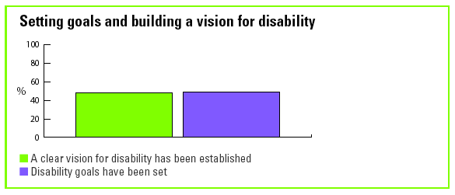

Disabled people are not consulted

It would seem that the external environment, including legislation, demographic
changes, social and labour market changes, are driving disability policy, rather than consultation with disabled people themselves.

- 61% of respondents report that developments in the external environment have influenced their disability goals.
- 26% use the results of consultation with disabled employees to help set disability goals.
- 29% use the results of consultation with disabled customers to help set disability goals.

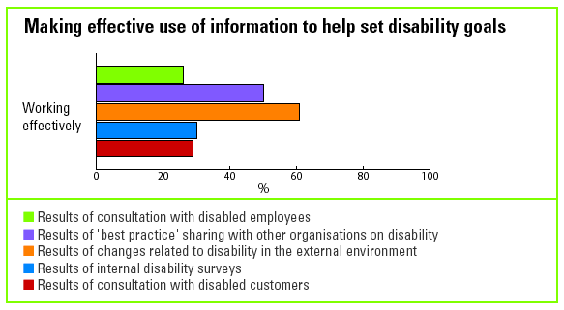

Get the basic policies right

- 48% of respondents have the policies and standards in place to support disability in employment.
- Only 38% have policies in place to support disability in service provision.

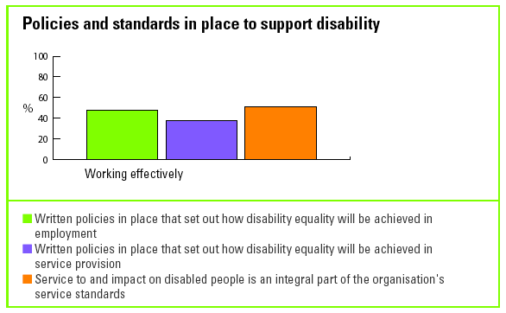

Policies are fundamental

- Notably, of those organisations scoring above the benchmark average - 57% to 67% have policies to support disability in employment and 49% have policies to support disability in service/product delivery.
- In contrast, only 24% of organisations that scored below the benchmark average have these policies.

A strong economic and ethical case for disability improves disability confidence

Nearly half the respondents overall (46%) have made an economic, business and ethical case for disability in their organisations.

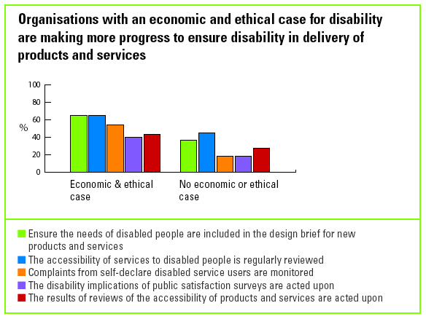

Disability is much more than an HR priority

There is a clear need to spread responsibility for becoming disability confident more widely across the organisation.

- 53% of respondents reported that their HR departments and 55% reported that their property services departments - have an action plan on disability.
- 36% or less have developed action plans for disability in any other department.

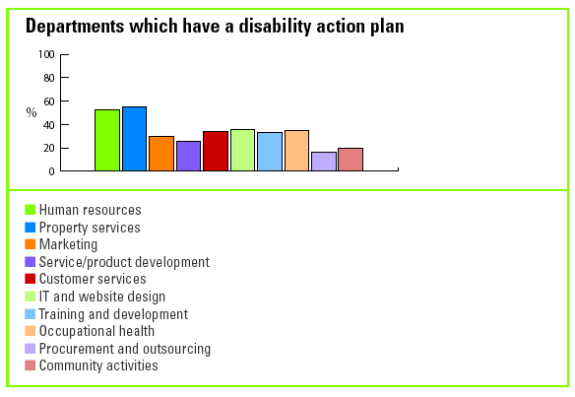

Motivate: Good practice examples

What is your organisation's commitment to disability?

Some examples of in-house statements…

B&Q

B&Q is committed to learning about the needs of disabled people as customers,
employees and in the local community, and wants to further understand the barriers to employment and shopping that people with disabilities can sometimes face as part of everyday life.

Department for Work and Pensions

As the employer of a large and diverse workforce, DWP is committed to continuous improvement in its performance as an employer of disabled people and wants everyone to maximise their contribution to delivering the business. DWP actively promotes the development of a diverse workforce that is representative of the community it serves and constantly seeks to raise awareness of how diversity and equality issues impact both on its staff and its customers.

HSBC

Diversity is a source of opportunity, whether in employment or customer markets.
Application of a rich mosaic of difference within the workforce fuels group dynamics and helps create an environment where teams can perform to their full potential. A generalised market approach will not reach the many pockets of value to be found in diverse groups of customers. Competitive edge can be gained from the variety present in our workforce and customer base, and specific attention to market variation, in, for example disability.

How do your senior level managers demonstrate their commitment to disability?

Lloyds TSB
Statement from the Deputy group chief executive

Around 10 million people in the UK have a disability, which means that over 16% of the population is disabled. A substantial number of our employees, customers and shareholders will either have a disability themselves, or will have someone in their immediate circle of relatives or friends who is disabled.

We are proud to be playing our part in tackling the barriers that disabled people face. As a business, we aim to recruit the best employees and we know that, given the opportunity, disabled people have as much to offer as anyone else.
Mike Fairey
Deputy group chief executive

The Department for Transport

The Department for Transport Diversity Champion is David Rowlands - the Permanent Secretary. David has demonstrated his commitment to disability by, for example, accompanying a member of staff around the Great Minster House headquarters to get a better understanding of the difficulties which some disabled staff have getting around the building, as well as to learn what we are doing to make access easier both for disabled staff and visitors. He holds regular meetings with the different staff networks, including disability, from around the Department. From these meetings, David is able to keep pace with some of the aspirations of individuals in the Department in terms of diversity and to follow up on some of their concerns. In June he visited the annual Mobility Roadshow in Derby, where he saw some of the excellent work, within and outside the Department, related to giving disabled people the independence to travel.
David also takes an overall view by monitoring how the Department and agencies are progressing in meeting the new requirements of the Disability Discrimination Act.

HM Treasury

The then Permanent Secretary, Gus O'Donnell, launched the Disability Strategy on 28th April 2004:

'I am very pleased to be launching a network of senior staff responsible for ensuring that we maximise the potential of staff in the Department who have a disability. The network is part of the Treasury's commitment to ensuring that people with different skills, backgrounds and experiences can work and thrive here and contribute effectively to our success. Each directorate will have its own disability champion. They will be available to everyone in the directorate to help understand the issues around disability and create better business and working practices.'

Motability Operations

Disability goals and updates on progress are always included in company-wide
“roadshows” delivered by senior managers/directors. Disability features as one of our three strategic objectives.

Royal Bank of Scotland

Alongside the diversity and disability champions, RBS is currently rolling out drama based diversity training, called Respect in the Workplace, and this has now been completed for over 1000 of our executive and senior managers. Over the course of 2005 it is planned that this training will be delivered to the remaining senior management across the Group.

What is your organisation's vision for disability?

Nationwide Building Society

Nationwide aims to match the expectations of our members and employees with
disabilities by providing the same level of service and opportunities as for non-disabled members and employees.

The Victoria and Albert Museum mission

Access: To offer the widest and most appropriate forms of access to the Museum's collections, expertise, facilities and services, actively working to overcome physical, sensory, intellectual, cultural, attitudinal and financial barriers which prevent this. The emphasis is on the removal of barriers to the V&A's collections, knowledge and expertise thus broadening the V&A's audience, particularly those under served by the V&A, e.g. people with disabilities, socio-economic classes C2,D,E and culturally diverse communities.

Inclusion: To work in partnership with others to tackle social inequality, discrimination and disadvantage; empowering communities, improving the quality of people's lives, contributing to social cohesion and acting as a catalyst for cultural and social change. The emphasis here is on working with others to encourage social cohesion and the inclusion of individuals or communities who suffer from linked problems such as unemployment, poor skills, low incomes, discrimination, poor housing, high crime environments, bad health and family breakdown or few opportunities for participation in social or cultural life.

Diversity: To embrace and reflect diversity, harnessing the potential of all stakeholders (staff, volunteers, existing and potential audiences, key partners) in the development of a truly inclusive Museum which inspires, promotes learning, creativity and participation. The emphasis is on ensuring that all aspects of the V&A - the staff profile, the collections, audiences, programmes and events reflect the diversity in society including in relation to socio-economic and educational background, disability, age, ethnic background, religious belief, country of origin, residency and sexual orientation.

Sainsbury's

Vision

1. To ensure that Sainsbury's meets the requirements of the Disability Discrimination Act (DDA):
Customers - Ensure specific disability facilities and services are available enabling all customers to have an easy and enjoyable shopping experience
Colleagues - To have a fair representation of disabled colleagues in our stores and that all colleagues are able to deal with disability related issues effectively
Buildings - Stores and services are accessible for all customers (including disabled and elderly customers) in line with the DDA part III.

2. To seek tactical opportunities to go beyond meeting the requirements of the DDA, which are low cost and provide an improved service to customers.

Our vision also supports the corporate goal which is to 'deliver an ever improving
quality shopping experience for all our customers with great products and fair prices. We will exceed customer expectations for healthy, safe, fresh and tasty food making their lives easier every day.'

Royal Mail

At Royal Mail Group we welcome diversity and are proud to employ a rich and diverse mix of people who reflect the communities where we live and work. We are working to ensure that equality of opportunity is something with which Royal Mail Group is identified - this is critical if we are to achieve commercial success and be an employer of choice.

At Royal Mail Group we are working to ensure that equality of opportunity is embedded in our understanding and reflected in our people:

Our people are entitled to work in an environment without fear of discrimination,
harassment, bullying or prejudice, regardless of their gender, race, ethnic origin,
disability, age, marital or family status, religious belief or sexual orientation.

We need to ensure that every employee and customer is treated with dignity and
respect, and feel valued.

Our customers are diverse and expect to be served by people with whom they can identify - we must meet this expectation.

We strive to attract, develop, promote and retain the best talent because it is our
people who set us apart from the rest and who truly make the difference.

What are your disability goals?

BBC

The BBC's goals include:

- Achieving a workforce with 4% disabled people by December 2007
- Ensuring accurate portrayal of disabled people
- Achieving targets for the increased representation of disabled people in BBC television output
- Making bbc.co.uk 100% accessible to disabled people
- Nurturing new talent through the Disability Writersroom - a collaboration between BBC Radio Drama, Graeae Theatre Company and BBC New Writing and the Talent
- Fund for Disabled Actors
- Providing 100% subtitling across the BBC's entire network by 2008
- The provision of audio description and signing
- Continue to offer work placement opportunities for disabled people through the BBC scheme 'Extend'.

What is your economic and ethical case for disability?

KPMG

Our economic case for disability is built upon our need to recruit and retain top talent, which means recruiting and retaining from the widest possible talent pool. There is also a clear economic case for disability linked to the interests and needs of our clients, who may be organisations themselves committed to taking action on disability or individuals with disabilities. There is also the legal case and risk management, and, of course, our reputation as a leading professional services firm. The ethical case for disability is built very strongly on our organisational values, one of which is 'We respect the individual'. Making this real requires paying particular attention to diversity, including disability.

Lloyds TSB

Employees
We believe that to attract and retain the best employees, all our policies, procedures and processes must be open, honest and fully inclusive of people with disabilities. In the current shrinking labour market, where it is vital to compete for the best staff, we must target high calibre employees across the widest possible pools of talent. This includes actively targeting disabled people, as we recognise that they represent an opportunity we cannot afford to miss. Through disabled people's unique perceptions and experiences of life, as well as their comparable skills, experience and qualifications, they can bring a wealth of innovative and transferable skills to the workplace.

We also recognise that we must make every effort to retain people who become
disabled during their employment with Lloyds TSB. The majority of disabled people become disabled during their working lives and their loss from the workforce would mean the loss of valuable skills and knowledge. It makes sound financial sense to retain them, as most adjustments for disabled employees cost less than £300. This compares very favourably with the estimated costs of replacing someone which can be in the region of £10,000 to recruit and train a clerical officer, and up to £40,000 for a senior manager.

Customers
There are three very simple reasons why we make the quality of service to disabled customers a priority:

- We care about all our customers irrespective of any disabilities, and any improvements we can make for our disabled customers will more than likely improve things for others, e.g. access for wheelchairs means easier access for parents with pushchairs.
- Customers with disabilities are as valuable to us as any other customers - disabled people need financial services just like the rest of society.
- We take our responsibilities under the DDA seriously; we do not want to run the risk of legal action with bad publicity, loss of business and legal costs.

Act: Results highlights

The Act section of the Survey presents those areas of organisational policy and
practice which require a disability dimension to ensure:

- disability equality in recruitment and selection
- disabled employees are able to reach their full potential
- and disabled customers are able to enjoy the same level of service as non-disabled customers.

The table below shows overall average scores of all 80 participants for this section

 | Score %
Act section average | 65
Recruitment & selection | 72
Training & development, promotion, appraisal & pay | 66
Work, workplace design & employee support | 79
Behaviours & cultures | 58
Involving & communicating with key stakeholders | 60
Accessibility of products & services | 53

Most benchmarking organisations are:

- working towards ensuring disability equality in recruitment and selection
- operating objective appraisal and promotion criteria
- ensuring disabled employees are not disadvantaged in their contract and conditions
- working to make their built environments accessible to employees and customers
- working to retain employees who become disabled.

Benchmarking organisations are working to ensure fair
recruitment and selection for disabled applicants

Over 70% of respondents take action to avoid disability discrimination in their
recruitment and selection processes and 56% provide disability specific equality
training to everyone involved.

However, only 30% of respondents currently consider disability when appointing their recruitment agencies.

Organisations are taking action to ensure the built environment is accessible

75% of respondents have undertaken an accessibility audit of their premises and have drawn up a schedule for improvements that covers building, design and equipment.

Work is also under way to ensure products and services are accessible

Most benchmarking organisations are taking some action to ensure their products and services are accessible:

- 48% of respondents are confident that the needs of disabled people are included in the design brief for new products and services.
- 50% review the accessibility of their products and services regularly.
- The only way the majority of respondents can discover if they are meeting the needs of their disabled customers is through their ordinary complaints procedures – which 74% report are accessible.

However, much more needs to be done if…

employers are to respond efficiently to employee requests for reasonable adjustments

- 76% of respondents report that they offer adjustments to applicants in their recruitment and selection process.
- 78% report that they take action to retain employees when they become disabled - which may include making reasonable adjustments.
- However, only 34% of respondents report that they have written guidance or policies covering how to make a reasonable adjustment request and how to respond to these requests.

...and disabled employees are to reach their full potential

- 53% of respondents are confident that the training they provide is accessible.
- 43% provide effective training for employees involved with conducting appraisals.
- 54% provide effective training so that those involved with making promotion decisions ensure disabled employees are not disadvantaged.

More action is needed to develop disability confident
behaviours and cultures...

- Only 28% of respondents provide effective training for employees to support the achievement of their disability goals and a further 59% are working towards this and are either reviewing their training, are planning training or have just introduced it.

...and to ensure information is provided in accessible formats

- Fewer than 50% of respondents ensure information that needs to be communicated to employees and customers is provided in accessible formats.
- Only 35% have fully accessible websites.

Conclusions

The lack of investment in training, culture change and ensuring accessible products and services suggests that many organisations still do not understand why they should become disability confident or what competencies they need if they are to turn legal and ethical obligation into mutual benefit. They may also be unaware of what they can do in concrete terms which will move them forward towards disability confidence.

Those organisations with results of above 75% clearly do understand the implications of becoming disability confident. These higher performing organisations focus on changing their cultures and behaviours so that they can effectively consult and communicate with disabled employees and customers and are working to meet their needs and aspirations.

Priorities for action

It is important to be seen by employees, customers and stakeholders to be working to the spirit of disability legislation and to be genuinely committed to becoming disability confident.

- Set a policy and guidance for meeting employee requests for reasonable adjustments.
- Set a standard which explicitly addresses how quickly you will respond to requests for adjustments and how efficiently the process will be managed.
- Move into action to develop disability confident cultures and behaviours.
- Consult with your disabled customers and potential customers to ensure you are meeting their needs and aspirations.
- Take action to ensure your products and services are accessible.
- Make information accessible to employees and customers.
- Work with your suppliers to ensure they support your disability goals and standards.

Act: Detailed results

Attracting the best candidates from the widest possible pool

Action is being taken to avoid discrimination in recruitment and selection...

Over 70% of respondents are taking action to avoid discrimination in recruitment and selection by:

- avoiding unnecessary criteria in job and person specifications (74%)
- offering adjustments to candidates at every stage of the process (76%)
- checking medical questionnaires and occupational health policies (70%)
- 56% of respondents provide disability specific equality training to everyone involved with recruitment and 54% make sure that managers are informed about the government's Access to Work scheme.

...but more can be done to minimise legal and reputational risk when outsourcing recruitment

- Only 30% of respondents consider disability competence when appointing their recruitment agencies.

Little is being done to attract disabled candidates

- Only 34% take action that is effective in attracting disabled people to apply for jobs.
- 21% have yet to take any action on this.

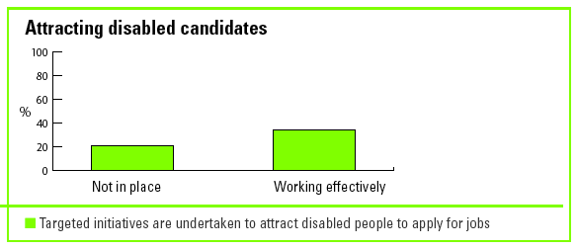

Taking action to ensure disabled employees reach their full potential in the workplace

More needs to be done to ensure disabled employees can access training

- 53% of respondents take action to ensure the training they provide is accessible.
- 46% ensure that bias is removed from the criteria and systems used to select employees for training.
- Only 23% of respondents offer development activities specifically to known disabled employees.

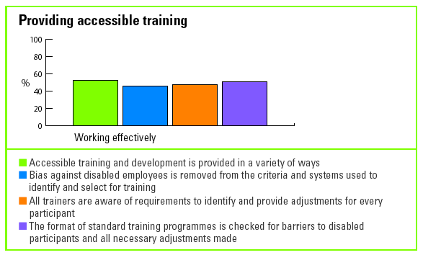

Appraisal and promotion systems are designed to operate fairly but more can be done to ensure they are followed in practice

- 88% of benchmarking organisations are confident that their appraisal criteria are fair and 70% are confident that their promotion criteria are fair.
- Only 54% provide training for those involved with promotion decisions.
- 43% provide training for employees involved with delivering appraisals to ensure disabled employees are not disadvantaged in any way - directly, or indirectly through bias or lack of awareness.

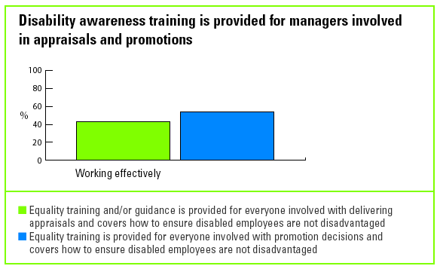

Making premises accessible

Accessible premises are a priority for benchmarking organisations

75% of respondents have conducted an accessibility audit throughout all their premises and have drawn up a schedule for improvements that covers building and design and equipment.

Providing reasonable adjustments

More work is needed to manage requests for reasonable

Adjustments

Although the benchmarking organisations have done much to ensure their buildings are accessible, less emphasis appears to have been placed on responding to requests for reasonable adjustments from employees.

- 34% have effective policies, procedures and guidance in place to support requests for reasonable adjustments.
- 30% have a widely published standard that any employee requesting an adjustment will have their request process started within 28 days.
- 76% of respondents report that they offer adjustments to job candidates at every stage of the recruitment process and 78% have procedures for retaining employees who become disabled.
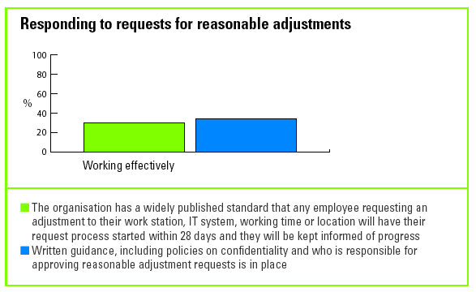

Adjustments are crucial to getting it right

Notably, 44% of those organisations that scored above 57% - the benchmark average - have reasonable adjustment policies and procedures in place compared to only 22% of those scoring below the benchmark average. 61% of those that scored above 75% have these policies in place.

Developing disability confident behaviours and cultures

Little is being done to build disability confident behaviours and cultures

- Only 28% of respondents report that they have effective training in place to support the organisation's disability goals.

Where training is provided, the focus is on disability related legislation and organisational policies rather than on attitudes and changing behaviours.

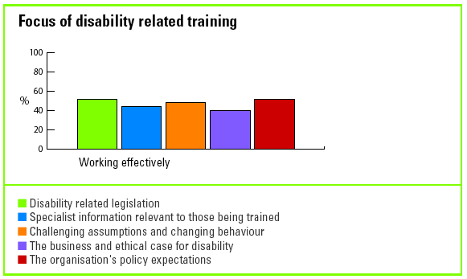

- 46% of respondents are effectively using disabled trainers or disabled experts to help bring about changes in attitudes and behaviours.
- The only way most respondents (94%) try to ensure non-discriminatory behaviour is by making their procedures for grievance, harassment and disciplinary issues, including those related to disability, accessible to every employee.

More communication is needed to help develop disability confidence

- Only 30% of respondents have an effective communications strategy in place designed to support the behaviours and cultures needed to become disability confident.

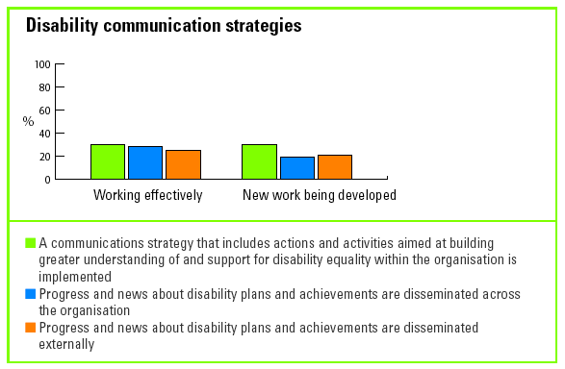

Communicating with disabled stakeholders

Much more work is needed to make communications accessible

- 63% of respondents ensure that their reports and accounts are written in straightforward language and are available in alternative formats.
- Despite the legal risk, only 48% of respondents ensure that information that needs to be communicated to employees and customers is accessible.

Accessible information is crucial to getting it right

Notably, 67% of organisations that scored above 57% - the benchmark average -
ensure that all information for employees and customers is accessible compared to the 24% that scored below the benchmark average. 89% of those who scored above 75% ensure all their information is accessible.

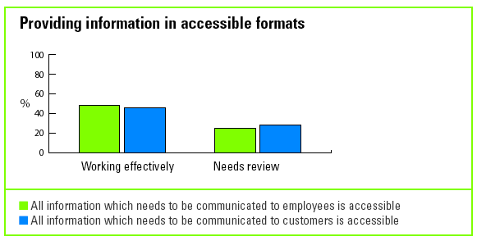

- Only 35% of benchmarking organisations have fully accessible websites or ensure that the information or services on them can be provided in other ways. Promisingly, a further 56% are working towards this standard.

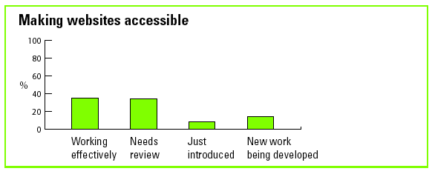

Website access is crucial to getting it right

51% of organisations that scored above 57% - the benchmark average - report that their websites are fully accessible compared with 16% of those that scored below the benchmark average. 61% of organisations scoring above 75% have accessible websites and the rest are actively working towards this.

Consulting with disabled customers

Little action is taken to consult with disabled customers

- The only way the majority of respondents can find out whether they are meeting the needs of their disabled customers is through their complaints procedures – which 74% report are accessible.
- 21% identify the views of self-declared disabled people in their customer satisfaction surveys: 49% have yet to do anything on this.

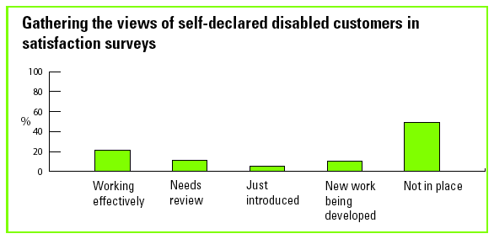

Consulting with disabled employees

Consultation with disabled employees is more likely than with disabled customers

Much more effort is being directed into consulting with disabled employees on their experience of working for the organisation. Almost every respondent is now taking some action on this, with 41% reporting that their approach - through networks or employee surveys - is working effectively.

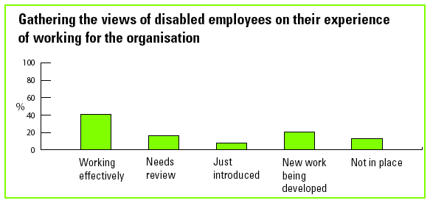

Building a disability confident reputation

Work is underway to build a reputation for being disability confident

An organisation’s reputation for being disability confident will help to attract and
reassure disabled customers and job applicants, and build bridges to disabled
stakeholders more generally.

- 37% of respondents report that they are beginning to take action to ensure their organisational literature and campaigns include positive images of disabled people, although only 38% already do this well.

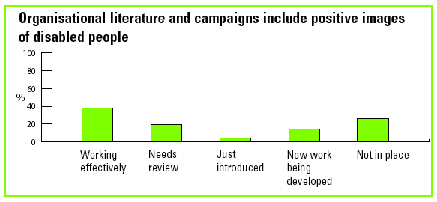

An organisation’s corporate responsibility activities should play an important role in building a reputation for disability confidence.

- 45% of respondents say they do not have a social responsibility agenda (including 26 public organisations). But of those that do, 70% report that a disability dimension is included and working effectively.

Making products and services accessible

Work is underway to make products and services accessible

- 48% of respondents include the needs of disabled people in the design brief for new products and services.
- 50% review the accessibility of their products and services on a regular basis.
- However, only 24% design their market research to identify the specific needs and preferences of disabled customers: 39% have yet to take any such action.

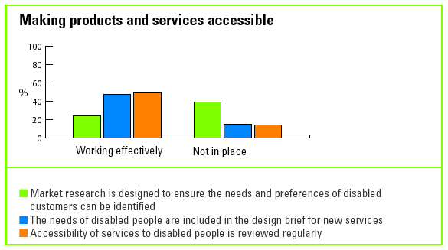

Organisations are taking steps to check that providers of outsourced services are also disability confident

30% ask all their providers of outsourced services to demonstrate they are working in the spirit of disability legislation.

However as a further 40% are working towards this we will see ever increasing
pressure on organisations supplying goods and services to prove they are disability confident in order to win contracts.

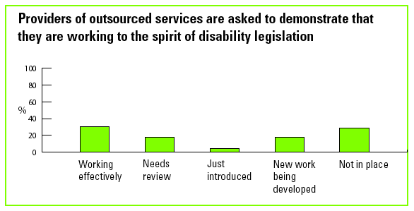

The public sector duty to promote equality of opportunity for disabled people

The public sector will, from 2006, have a legal duty to promote disability equality and to ensure that their policies, and the way in which they deliver their services and carry out public functions, do not adversely affect people with disabilities.

Progress is being made towards fully accessible services – but much more needs to be done

- Most progress has already been made by the public sector respondents with 49% ensuring that external facing employees are aware of their new legal obligations in delivering services and carrying out public functions.
- Most public sector organisations (79%) are already taking some level of action to work with other public bodies to ensure disabled people are not discriminated against or treated less favourably when carrying out public functions and delivering services, although just 41% say this is working effectively.
- However only 37% are effectively able to review their services and public functions to ensure they do not have a less favourable impact on or outcome for disabled people.
- 17% of public sector respondents are able to effectively establish the extent to which disabled people are accessing their services. 39% have yet to take action on this.

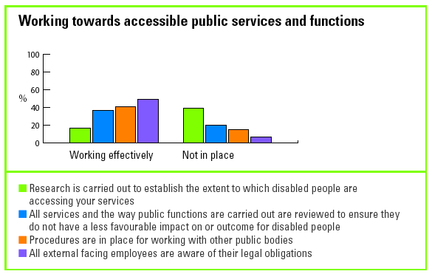

Act: Good practice examples

Recruitment and selection

How are you working with recruitment agencies to attract disabled candidates?

British Council

At the British Council we use Adecco to fill our temporary staff vacancies. We have built a commitment to diversity - with specific reference to disability, ethnicity, gender and age - into their brief. We ask for quarterly reports that show the profile of all staff sent to us and annual analysis of this data is undertaken by an external EO monitoring specialist. On finding out that we were using Jobcentre Plus and their Disability Advisers to advertise British Council permanent external vacancies, Adecco have now developed a relationship with the Disability Advisers at Jobcentre Plus to explore ways to widen their pool of recruits. Like the British Council, Adecco are members of the Employers' Forum on Disability and monitor the diversity of their own workforce as well as their clients'.

Centrica

A central Resourcing team has been set up and has developed new standards for working with recruitment agencies, which include disability equality. The Resourcing team have been involved in ensuring that our preferred supplier list for strategic recruitment partners is tasked with increasing the diversity of short listed candidates, including disabled people.

Additionally, all suppliers will be reminded of their responsibilities in a revised
procurement procedure. We have held supplier workshops which included a session on diversity and inclusion and discussion around disability. We are carrying out a review of all supplier led agreements and are encouraging all our suppliers to work with Jobcentre Plus. We are supporting the Employers’ Forum project to develop detailed guidance for procurement departments when outsourcing recruitment.

Leicestershire Constabulary

Every recruitment agency which wishes to supply staff to the Constabulary must submit their diversity policies and commitments for scrutiny. As a result more than 20 employment agencies have been refused as a supplier in the last five years. The lack of disability commitments and policies has been the top reason why most have been rejected. We have seen that several agencies have not kept up to date with legislation, have not made commitments to make reasonable adjustments and have done nothing to encourage under represented groups to use their services.

What recruitment and selection training do you provide?

BBC

Everyone involved in the recruiting process must have completed either:

- Face-to-face training on recruitment processes including fair selection procedures
or
- Online Fair Selection course or
- Face-to-face training from their recruitment account manager/consultant.

All these courses cover disability recruitment. All recruitment account teams have had specific disability awareness training. Everyone involved in recruitment must have refresher training and coaching every three years.

Royal Mail

The Royal Mail recruitment process endeavours to ensure all recruitment decisions reflect our commitment to be fair and non-discriminatory. Diversity Awareness training helps reinforce this policy. As well as Diversity Awareness training, our recruitment colleagues have all received 'Guidelines for Conducting Front Line Interviews' This document informs assessors and recruitment personnel of the importance of recruiting the best person for the job, and of valuing diversity. These guidelines aim to eliminate discrimination, bias, poor questioning techniques and inadequate note taking – all factors of unsuccessful interviewing.

The 'Recruitment and Interviewing Technique' training delivered to each assessor contains a module on employment legislation, covering the Disability Discrimination Act and our Valuing Diversity Policy. This course reinforces the message conveyed through our Diversity Awareness Training and ensures that our assessors are fully aware of the legislation. The course is assessed by an external assessor who tests participants on their ability to ask appropriate questions and treat candidates fairly.

Royal Bank of Scotland

Please summarise the key aspects of the training you provide for those involved in recruitment and selection that refers to disability training.

In 2004 the Group launched an Accredited Interview Skills training course which has been accredited by The Institute of Financial Services (IFS). The accreditation process recognises good practice in terms of interview skills including legal compliance, accurate note taking, making defensible selection decisions against clear job requirements and engaging well with candidates.

What action are you taking to attract disabled job applicants?

Barclays

At Barclays we run a number of schemes to attract people with disabilities to apply for jobs, including work shadowing. In our service based business we ran a Recruitment that Works project targeted on disabled applicants in our Poole processing centre. This resulted in one part time place and six full time places being filled. The project has now been handed over to our Resourcing team who will deliver the scheme with other business areas.

B&Q

To demonstrate that we welcome applications from candidates with disabilities our recruitment literature includes specific reference to disability and reasonable
adjustment. In addition, our call operators at B&Q recruitment have all received
disability awareness training and are coached in reasonable adjustments for different types of disabilities. Our recruitment website is fully accessible with a text only site. We also use a range of media to advertise vacancies including Disability Now and Able magazine.

Centrica

In 1998, Centrica introduced a recruitment initiative, called Project Led Recruitment (PRL), successfully creating new employment opportunities for carers and people with disabilities in its offices in the North West of England.

The initial aims were to provide a clear, short route into employment with the support of pre-employment training and development, to enable disabled people and carers to acquire the necessary skills, to enable them to work in call-centres, to develop them in their roles and improve the capacity of employers to place disabled people and carers into jobs.

Through a partnership with the Employers' Forum on Disability, Carers UK, and Jobcentre Plus, a process model (Recruitment that works) was developed that enables other employers to learn from our experience.

Of the original 50 people employed, more than 40 were given permanent contracts with the company. We have now extended the project to 10 further locations. To date more than 200 people have been employed, of whom around 45% have a disability.

Based on the Centrica experience, the Employers' Forum on Disability produced the ‘Recruitment that works’ guide which highlights the benefits of our experience and provides a framework for other employers.

Centrica sponsored the re-launch of the RTW guide and has been involved with
government in consultation around the recruitment and employment of people with disabilities, in conjunction with the Forum. Centrica has been working hard to influence suppliers such as Blue Arrow, who are now working closely with Jobcentre Plus in order to target people from all groups in the community. Centrica and Jobcentre Plus have been working with selected voluntary organisations to create further employment opportunities for people with disabilities.

HBOS

We are a two tick employer (the disability symbol from Jobcentre Plus). We use a
diversity statement, the two ticks symbol and a wheelchair sign banner in our
recruitment advertising to communicate our commitment to employing people with disabilities.

Our Physical Access programme ensures that disabled people can work in all
our outlets.

We have undertaken several outreach measures in Northern Ireland to attract disabled people to apply for jobs. The Northern Ireland recruitment team won this year's HBOS Equality and Diversity Award in recognition of their commitment to employing disabled people.

We work closely with the RNIB and RNID to help us change our processes to enable people with a visual or hearing impairment to work with us. We also work with local disability groups to encourage applications.

We have an internet trafficking pilot in place through 'YourAble' to direct disabled
people to our recruitment site and one area of our business advertises vacancies on Jobability.com. We also employ Remploy inter-workers and work with Shaw Trust to provide work placement opportunities. Most recently we have been piloting an internet trafficking initiative to direct people with a disability from YourAble to our internet recruitment site.

Lehman Brothers

We have partnered with a variety of organisations to extend our reach to the disabled community, including: RNID, RNIB, SCOPE, Blind in Business, Prospects, Mencap, Employment Opportunities, SKILL, the MS Society and Blesma. Each member of our Disability Working Forum has a relationship to manage with one of the organisations.

Examples, of specific actions we have taken to attract disabled candidates to apply for jobs include:

- Sponsoring the RNIB Charter
- RNIB distributing a recruitment poster to all of their offices across the UK
- Linking our job posting site to the Employment Opportunities website and Youreable.com
- Sponsoring the SCOPE Fast Track programme
- Holding an awareness day to market investment banking to our disability partners giving them the opportunity to educate our employees about their organisation and services
- Holding an awareness day for 11 blind and partially sighted individuals to broaden their understanding of what opportunities there are in investment banking
- Co-sponsoring Disability Chances - a programme for disabled graduates to learn more about the industry
- Joining the WorkRight programme run by Mencap
- Running an 8 week summer internship programme for 16 disabled students through Employment Opportunities.

Training and development

What action do you take to ensure your trainers provide
accessible learning opportunities?

Jobcentre Plus

All our trainers attend Diversity workshops. We also hold regular ad hoc discussions with our trainers and administrative staff on how to meet the needs of disabled staff. Examples of actions undertaken to empower disabled staff include:

- Arranging for large print versions of handouts
- Delivering events with sign language interpreters present
- Hiring loop systems for students with hearing loss
- Switching venues where wheel chair access is difficult.

All our L&D developers are made aware of the issues of diversity (including disability) and the implications for product development. In developing materials accessibility is a key consideration. Products are developed in small bite size learning packages which facilitate access for a wide range of delegates. Modular training is also made available in alternative formats so that the learning can be accessed in the workplace. The development of e-learning further supports accessibility.

External providers are asked, as part of the bidding process, to explain their diversity practices and activities. Start-up meetings are held with external learning providers where disability is discussed as is the issue of accessibility to learning by the customer group. Providers are made aware of Jobcentre Plus policy on accessibility of learning. Contract managers monitor to ensure that learning is developed in a way that facilitates take up by people with disabilities, including alternative formats where required.

What do you do to avoid bias and discrimination in your
appraisal process?

Department for Work and Pensions

DWP takes a number of steps to avoid bias and discrimination on any grounds -
including disability - in the appraisal process. Guidance is included in its Performance and Development System policy; its Diversity Toolkit and in Selection and Interview Training. These measures are further supported by the distribution of the Disability Confident video and guidance that includes a section on setting SMART objectives for all staff. It notes how, for disabled staff, objectives should be set taking into account their disability, so that they are not disadvantaged by the process.

This year additional corporate guidance was published on how objectives might be adjusted to take account of disability. Hyperlinks to the Diversity and Equality intranet site, remind managers and staff of their responsibilities in ensuring that minority groups, including disabled people, are not unfairly disadvantaged.

What specific development activities do you offer your disabled
employees?

Barclays

Barclays have developed and now run the Career Development Event for People with Disabilities. The course, run by Stephen Duckworth of Disability Matters Ltd, aims to help participants:
- develop skills and techniques to positively manage their career
- create positive changes in their life - work, learning and other areas
- identify personal and work goals
- deal with unforeseen barriers and disappointments
- practice and apply various techniques for developing and achieving goals relating to career, work or training and other areas of life
- develop a plan that with further support will help shape their future.

This course has been run three times and now forms part of our standard training
offering. We have seen tremendous results in boosting self-confidence and career planning. One participant reflected:

'My attendance at the Career Development Workshop enabled me to understand more clearly how to use my ability in a way that would have the most positive outcome. What I learned became the tool for achieving whatever I chose to attempt. I obtained a promotion within six months of attending the course. It helped me to establish a network of contacts in Barclays who share similar disabilities or barriers, which has broadened my understanding of needs and has given me the confidence to challenge inequality and overcome the barriers placed before me.'

Lloyds TSB

The Lloyds TSB Personal Development Programme (PDP) for disabled staff was
introduced by the Equality & Diversity department after extensive research and staff consultation. The programme has been designed to be an inspiring and empowering experience and is open to every disabled employee.

It is a three-day residential course, with a one-day follow up five months later, in a fully accessible training centre. A group of up to 12 disabled employees are brought together with an internal Lloyds TSB Group trainer and one of the country's top external disability consultants who deliver the programme. The participants are given powerful tools and techniques to aid their personal and career development.

The course also includes a formal meal with an inspirational after dinner speaker who is disabled and has achieved considerable success. A unique feature of this development programme is the creation of a positive and supportive environment in which participants can have frank and constructive discussions about disability and its impact on their lives.

Feedback from participants and their line managers has been very positive. They report far greater confidence and assertiveness in dealing with workplace issues.

HM Revenue & Customs

The department participates in the Civil Service Disability Bursary Scheme (a former bursary holder is now responsible for diversity policy and strategy for HM Revenue & Customs). The Breakthrough Programme, an inclusive development, designed specifically for under-represented groups (including disabled staff) to empower them to reach their full potential. Adjustments are, and continue to be made to ensure that training and development opportunities are accessible to all staff and programmes are developed taking into account any accessibility issues.

Retaining disabled employees

What do you have in place to help retain employees who
become disabled?

Disability Rights Commission (DRC)

The DRC offers a number of flexible working patterns to facilitate the retention of
employees who become disabled, for example V Time. This scheme enables individuals to 'buy' additional leave by a monthly reduction in salary. Additional leave may be bought in amounts of 5 days up to a maximum of 20 days per annum.

Creating disability confident cultures and behaviours

What training do you provide to help develop disability confident
behaviours and cultures in your organisation?

Centrica

We have developed an E-learning package to be rolled out to every employee across the group. This package covers disability specifically and has been designed to ensure that barriers are removed and behaviour can be influenced to positively support customers and employees with disabilities.

Our Diversity and Inclusion Essential intranet site has been established with a separate disability section, to provide a point of reference for every employee. As part of our ongoing commitment to diversity and disability our line manager training includes disability and outlines responsibilities of individual employees and line managers. In addition, we are rolling out HR Manager training on diversity which includes a module on disability, making reasonable adjustments in the workplace and how HR Managers can support Line Managers and their employees.

Adult Learning Inspectorate

A series of 'diversity dilemmas' for training purposes have been developed which
include a number of case studies relating to disability. We intend to use these at our annual staff conference.

Reasonable adjustments

How do you ensure a prompt response to requests for
reasonable adjustments?

Lloyds TSB

The Disability Discrimination Act (DDA) means that all employers have a duty to make reasonable adjustments for employees with disabilities. Lloyds TSB sees this duty not just as a question of legal compliance. There are business benefits when we remove barriers that might prevent one of our employees from doing his or her job effectively. It shows we value our employees and impacts positively on employee engagement.

Since 2000, over 1800 Lloyds TSB Group employees have received reasonable
adjustments thanks to our Reasonable Adjustment Programme. This has enabled many to work more effectively and others to remain in work. The scheme was the first of its kind in the UK and has been copied by other employers.

In the first instance, if a member of staff needs an adjustment, the line manager
contacts the HR Call Centre who will start the Reasonable Adjustment process. We then refer the request to our specialist disability consultants who contact the line manager or local HR contact within 48 hours to discuss the case and agree an action plan. The consultants work with all parties concerned until the issues are resolved and the case can be closed.

As an individual's condition/impairment may alter over time, our line managers
undertake a review of the individual work arrangements at regular agreed intervals, not less than once a year. A review is also done if a role changes, or if the individual feels further adjustments may be needed.

Please provide a copy/summary of your guidance and standards
on reasonable adjustments.

Motability Operations

Our reasonable adjustment process has also been refined in early 2005 to identify needs as part of selection, recruitment and development. This process is available on our disability confidence website and is also discussed with leaders on the disability confidence workshop and on the absence management workshop. Both these workshops are delivered by an internal HR specialist and an external disability consultant.

Communication

How do you communicate your progress and news on disability?

Barclays

Internal communication takes various forms which include Awareness events, our internal magazine, and the intranet. In our central support business, a quarterly newsletter is issued on Diversity of which disability makes up part of the content. In our card business, the DDA steering committee meets monthly to share progress against the DDA action plan.

The Disability Taskforce meets bi-monthly to discuss progress against other disability matters. There are regular circulars and emails to share progress as well as a dedicated Intranet site and bulletin board, where colleagues can share news and views. A disability and health awareness week was recently held across all sites to raise awareness of disability related matters.

InterContinental Hotels Group (IHG)

A robust communications plan has been developed around IHG DDA/Disability
Confidence Strategy to ensure that both internal and external stakeholders are kept fully informed on the progress being made.

The Board are informed via formal strategy updates and the Senior Management Team report on their individual elements via the Disability Working Group.

Guests can obtain general information on the accessibility of facilities via the IHG
website. Additional information on the Organisation's progress and approach to
disability confidence is included in its Annual Report.
Employees are kept informed of disability issues through a number of communication channels. These include:

- Managers' briefing
- DDA Bulletins
- Refresher training
- Direct communication from IHG's UK&I Chief Operating Officer
- A dedicated section on the One Team intranet site
- Information cascaded via DDA Champions

Employees can also raise any question about disability via a special email address DDA.accessforall@ichotelsgroup.com

Other Stakeholders including parliamentarians, national and local disability
organisations and the media are kept informed via events and publications such as the recent DDA dinner and the local DDA communications pack which is issued to the local MP and others when a hotel has been refurnished to enhance accessibility.

London Borough of Camden

Recent editions of "Inside Camden" an in-house monthly staff magazine have carried specific features on the DDA and results of "Mystery Shopping" carried out by disabled people. A daily "Message of the Day" e-mail to staff provides links to our intranet which carries recently published customer care guidance, particularly in relation to disabled customers. This also provides updates on legislation and occasional seminars focus on disability issues. In June 2005 we ran a specific seminar involving an external speaker, which was followed by another in July which focused on disabled people's experiences in the workplace.

Externally "Camden Living" a publication which goes to every household in Camden is our main vehicle for informing residents about our disability work. In addition "Camden Talks" is our 1,000 strong "citizens panel" which we use for consultation and engagement with citizens, including disabled people. This is a useful conduit both to hear local views and to communicate Council actions. Liaison groups, a number of which are specifically for disabled people are organised on a tri-monthly basis and provide another vehicle for 2 way communication.

How do you make information accessible to employees
and customers?

Centrica

Centrica has had alternative media provision for many years; we communicate to our customers in large print, Braille, audio and other less common formats. These communications range from gas and electricity bills and statements, through to marketing inserts and terms and conditions. Ad-hoc employee communications are now also available in alternative formats upon request.

Web Accessibility Guidelines have been established and used since 1999 to ensure Centrica websites are accessible to all. All sites are being made accessible to WAI level 2 standard, whilst Centrica.Com is already fully accessible to this standard, and we have developed a cross company web-accessibility group.

We also communicate regularly with other stakeholders through our website, annual report, Corporate Responsibility report, our literature and our diversity representatives attend key disability events throughout the year.

HM Revenue & Customs

An accessibility workshop was held within our Business Services to raise awareness of accessibility issues with people involved in the development of our IT systems. Following on from this, a process design and assurance team has taken on this work and a sub group is now working on raising awareness and getting accessibility issues into the hearts and minds of those involved with IT developments.

DIG (disability information group) has published booklets on different disabilities. They have a virtual disability network on the public folder to ensure the communication chain remains open and that needs are met.

Our Visibility Impaired Media Unit (not only for visual disabilities) will prepare
information in a number of formats. We will also ensure that a signer of any other
request for adjustment is put into place on request for staff or customers as far as we reasonably can. To help facilitate this we have recently had a procurement tender exercise to set up a contract with a company who will supply signing and other facilities to all offices throughout the department. We hope that by putting this contract into place that adjustments of this kind will be put in place more effectively and efficiently for both staff and customers.

Focus groups are held to communicate with staff and customers. An outcome from one of these meetings was the purchase of the latest infrared hearing loops. We also have a specialist IT team who are dedicated to ensuring that individuals' requirements are met in the way of reasonable adjustments, and will visit the individual and arrange installation of IT equipment, training, reviewing the training and ensuring that the latest versions of software/hardware are issued as soon as they have tested the products to ensure compatibility with our systems.

All our reports/letters etc carry a statement advising that the correspondence is
available in alternative formats on request. Information about typetalk and minicom availability is included on our website and on our information booklets.

Providing accessible products and services

What action do you take to ensure your products and services
are accessible?

BBC

The BBC is committed to making its online, onscreen and on air services accessible to all its audiences. It is currently working towards ensuring 100% subtitling across the entire network by 2008 and is expanding its audio description and signing service. It is working to ensure that bbc.co.uk is 100% accessible to disabled users. As regards radio, placing content on-line enables greater accessibility. The BBC's public information can be obtained in audio, Braille and large print and other accessible formats.

Action has been taken to ensure that disabled people can access the BBC's output and be audience members. Eighty per cent of the output of BBC One and BBC Two is now subtitled and the BBC provides over 30,000 hours of subtitling on the other major BBC channels - BBC News 24, BBC Three, BBC Four, CBBC and CBeebies.

Our highly trained subtitling teams across the UK are equipped to deal with every
conceivable situation, and are frequently required to supply pre-recorded subtitles right up to the moment of transmission. Besides pre-recorded subtitles, we cover all the major live sports tournaments such as snooker, football, tennis and golf, as well as oneoff events.

Audio description is an ever expanding service offered across a number of channels including BBC One, BBC Two, BBC Three, BBC Four, CBBC and CBeebies. In addition to the subtitling service, signing gives deaf viewers another form of access. BSL is provided for 3% of the BBC's output, covering a variety of mainstream broadcasts and live news. BBC.co.uk is constantly being updated to ensure access.

BBC commercial video although not currently accessible will be more so once VHF is phased out and DVDs become the standard format, as they allow for subtitling and audio description.

All studios have been fitted with induction loops and laid out in line with the BBC's access standards, so that disabled people can take part in audience shows.

Finally producers of BBC programmes have access to the Production Handbook which gives then advice and guidance on meeting the needs of disabled contributors such as actors.

Microsoft

At Microsoft, we follow a robust policy and process to ensure the accessibility of all our products. There are three different approaches:

Product Development: all product groups are training in accessibility, covering design, development and testing. Program Managers then design the features of the product with accessibility in mind, focusing on the various accessibility standards and legislation (such as W3C, WCAG, section 508 of the US Rehabilitation Act, and other international standards and legislation).

Usability studies then take place using a database of almost 400 individuals selfidentifying with a disability (this covers vision, speech, mobility, hearing and cognitive disabilities). Developers then create the User Interface for the product taking advantage of core accessibility functionality built into the code base.

Testers test the product in a number of ways, including involving the usability
participants and doing compatibility testing with a number of assistive technologies that cover the 5 major disabilities categories (speech, hearing, vision, mobility and cognitive). The accessible Technology Group within Microsoft has a lab dedicated to providing these assistive technology devices and software to the product groups for their testing purposes.

Additionally Microsoft works closely with the manufacturers of assistive technology devices and software (such as screen readers, input devices etc.) through our Microsoft Assistive Technology Vendor Program (MATVP).

Nationwide Building Society

All our branches have been equipped with a Helping Hand unit, which contains a range of templates, magnifiers, pens with easy grip handles, clipboard and lap pad to assist disabled members.

Nearly every branch has level access; all are fitted with hearing loops and we have a contract with the RNID to provide interpreters where required. We have also arranged for the RNID to deliver sign language training to employees in five trial areas and, if successful, the opportunity will be offered to other employees across the country.

We work closely with the Centre for Accessible Environments and follow their UK
design guidelines to ensure that access to our cash machines is as easy as possible for everyone. All our external cash machines are installed within the recommended guidelines.

We can provide marketing leaflets and account statements in audio, large print or
Braille and provide signature stamps free of charge to disabled members who are unable to sign at all or cannot provide a consistent signature.

Our internet bank service is easily adapted for use by blind or partially sighted people.

We have a textphone in our Call Centre and employees are shown RNID BT Typetalk video during their disability awareness training.

Our purpose built Usability Centre in Swindon, which aims to make Nationwide easy to do business with and to make it easy for employees to deliver excellent customer service. We involve disabled people in Usability testing. Examples of adjustments made following testing include adjusting the design of our new signature pad which was set on a moving travel to allow a shorter than average person, or someone in a wheelchair, to simply press a button to adjust the height. Also, following consultation with disabled people, we designed a lap pad filled with lightweight polystyrene beads to accompany the clipboard in the Helping Hand Unit.

The Pension Service

The Pension Service initially used Mystery Shopping to check disabled access of face-to-face services. From September 2004, however, local service have ensured that they only set up surgeries where accessibility for disabled customers can be assured so this particular aspect of the mystery shopping programme has now been discontinued.

Customer representative groups for customers with disabilities help us devise the
customer's service standards and quality-assure that we are not disadvantaging
certain groups. Local Service is working with Local Authorities and DCS to ensure disabled customers take up all benefit entitlements available to them. We are working with RNIB/RNID to ensure The Pension Service achieves their standards. The Pension Forum with Customer representatives is held annually.

We empower disabled service users by giving them a range of ways to access the service - by phone, email, fax, textphone, Typetalk and face to face (either in premises close to their home or by home visit). We make our leaflets accessible in different formats. We ask for views on the service from disabled customers and act on the information and use mystery shopping to test textphone use.
We are undertaking the TPS Customer Survey 2005 which is a survey of customers contacting the TPS. From this group it will be possible to identify those who classify themselves as disabled. This will allow us to assess their views of services and get quantitative assessments of their satisfaction with delivery.

Leicestershire Constabulary

We ensure disability is on the agenda by increasing senior manager's knowledge
around this issue, thereby leading to more informed decision making. All front enquiry desks have an induction loop system, accompanied by a portable amplifier kit which also acts as a tester for the main loop system. In addition all community co-ordinators and front desks have been issued with a customer care kit which includes a number of disability aids for use when they meet people who may need additional help.

These kits include magnifying sheets, wide grips for pens, signature templates and a portable amplifier kit. In addition for conferences we have carried out disability access audits of the venue, provided sign language interpreters, accessibility aids and a list of all aids in conference packs.

We are planning to ensure that on our website which features each police station a description of the accessibility of each station and the aids available. It is hoped that this will encourage disabled people to use the stations or ask for available facilities.

The disability access audit picked up that many of our stations were not accessible to people with learning difficulties because they did not have entrance signs, and that members of the public were confused with some buildings. This has been addressed. We also use disabled people in some of our training events, particularly around vulnerable victims.

The Victoria and Albert Museum

Access for deaf people:
Popular talks, lectures or demonstrations at the V&A are sometimes translated into British Sign Language (BSL) or are given in Sign Supported English (SSE) by deaf lecturers. These signed talks take place once a month. There is also sound enhancement equipment available on all talks and tours, which is obtained from the information desks.

Access for people with a visual impairment:
The V&A has established an innovative programme of touch and audio tours and
drawing and photographic courses for blind and partially sighted visitors. These
provide an opportunity for handling objects and developing individual art and craft
skills. There are regular special visits to major exhibitions for visitors with visual
impairments. The visits offer some visual description and some opportunity to touch. Visitors are welcome to bring a sighted escort and a guide dog.

Access for people with learning disabilities:
We have established an innovative programme of touch and photographic courses for visitors with a learning disability. These provide an opportunity for handling objects and developing individual art and craft skills. There are regular special visits to major exhibitions.

User groups
Following the user group evaluations of tactile books and sound enhancements in autumn 2004, we have a brief for more regular disabled user involvement. The
establishment of a user group is currently subject to funding. The purpose of this group is to help guide and develop services and best practice in areas of the Museum's work, to achieve the requirements of the Act and be pro-active in developing audiences with disabilities. The user group will be made up of disabled people who have an interest in access, visiting museums, and helping improve services and facilities. Members of the group will include people with hearing impairment, visual impairment, learning disabilities and wheelchair users. They will provide the Museum with views on services, assessments of the facilities on offer and will highlight good and bad practice.

Impact: Results highlights

The third section of the Survey assesses the impact of what has been done to enable an organisation to become disability confident.

The table below shows overall average scores of all 80 participants for this section.

 | Score %
Impact section average | 42
Monitor recruitment & selection | 57
Assess & review training & development, promotion, appraisal & pay | 32
Research work, workplace design & employee support | 49
Assess & review behaviours & cultures | 47
Assess & review the results of consultation with key stakeholders | 48
Assess & review the accessibility of products & services | 43
Assess & review the impact of action on the organisation | 43

Too few organisations assess the impact of what they are doing on disability and then use that information to do better

Overall, respondents have scored lowest on those questions which ask if they are tracking the extent to which what they do on disability is getting the desired results.

For example, 26% of respondents use the information generated from customers who inform them that they are disabled.

34% of those which review the accessibility of their products or services are using this information to make improvements to design, policies or delivery.

This failure to assess impact makes it difficult to identify the costs and benefits of disability confidence

Only 19% of respondents effectively assess the cost to their organisation of not getting it right on disability. 44% have yet to take any action on this.

Only 9% effectively assess the benefits of taking action on disability in quantitative terms: 45% are doing nothing on this.

Without such information it is difficult to build the particular economic/business and ethical rationale for addressing disability as an organisational priority - and to sustain commitment.

Failure to assess impact makes it harder to justify engagement

It is difficult for any organisation to be sure that its systems and procedures to support disabled employees and customers are working in practice if it does not routinely track what's happening. For example, over 70% of respondents report that they are taking action to avoid discrimination in recruitment and selection but only 49% monitor the proportion of self-declared disabled people applying for posts and only 56% monitor how many then progress to final selection.

The high performers track impact

The Disability Standard leaders have collectively scored an average of 81% in this impact section - almost double that of the overall average.

The top 18 lead in:

- monitoring recruitment and selection and ensuring that employees involved with recruitment and selection receive regular disability specific equality training
- reviewing the impact of their disability equality training and making sure that at least 85% of their workforce understands how disability relates to their day-to-day jobs
- reviewing their speed of response to requests for reasonable adjustments to improve performance
- using the analysis of complaints from disabled customers; the results of customer satisfaction surveys and the results of accessibility reviews, to improve products and services
- using the results of consultation with disabled employees to improve performance
- checking that individual progress is being made against disability action plans across every area of the business.

Listening to employees and customers

The majority of respondents (84%) are taking some action towards using the results of consultation with their disabled employees to improve policies and procedures. Of these, 46% report they already do this effectively.

66% of respondents are taking some action towards using the results of complaints from disabled customers to improve their service or product delivery. 45% report they are already doing this effectively.

Conclusions

Failure to assess impact may well be linked to the difficulties associated with
encouraging people with disabilities to self-disclose, be they applicants, employees, customers or other stakeholders. It is difficult for any employer to measure progress by conventional means, given the great number of people with disabilities who do not declare themselves to be 'disabled'. Many either do not define themselves as disabled or prefer not to self declare for a variety of reasons, particularly the stigma and low expectations still associated with the 'label'.

However those organisations with a benchmark score of 75% and above are working hard to ensure they assess their return on investment in disability, and monitor on a much broader scale than just how many 'self-declare'. They are reviewing the impact of the changes they are making to policies, procedures and practices to ensure they make a difference.

The results show how important it is to plan from the outset to assess and learn from any disability related action, be it new product development; achievement of accessible intranets; evidence that suppliers are disability competent, the speed of response to requests for adjustments; the results of mystery shopping; or the numbers of employees who have had disability equality training.

Priorities for action

- Incorporate measuring impact into every disability action plan.
- Take action to create an environment where employees and customers feel secure to self-disclose their disability in the knowledge that information is being confidentially and proactively used to improve policies, practices and product/service quality
- Introduce disability monitoring into mainstream feedback systems, e.g. the whole recruitment and selection process; staff surveys; employee training; customer surveys; appraisals; applications for promotion.

Impact: Detailed results

Monitoring recruitment and selection

Most do not monitor the progress of self-declared disabled job applicants

80% of respondents are beginning to take action to avoid discrimination in their
recruitment and selection processes, however, only 49% are effectively monitoring the proportion of self-declared disabled people applying for posts and only 56% effectively monitor their progress through to final selection.

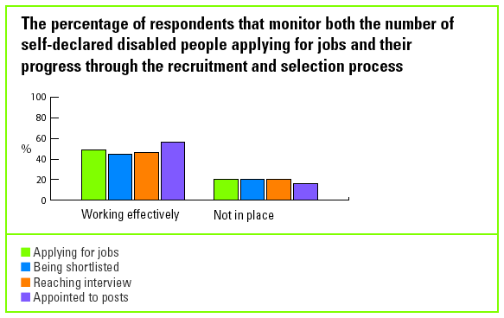

In contrast, 33% of those respondents who take specific initiatives to attract disabled people to apply for posts are also reviewing the impact of what they are doing and using what they learn to inform future initiatives.

Few know whether their disabled employees are reaching their full potential

53% of benchmarking organisations report that their training and development is
accessible to disabled employees; 70% report that their promotion criteria do not
disadvantage disabled employees in any way and 88% report that their appraisal
criteria do not disadvantage disabled employees.

However, only 9% of respondents compare the take-up of general training and
development by self-declared disabled and non-disabled employees; 23% compare promotion rates and 24% compare appraisal results.

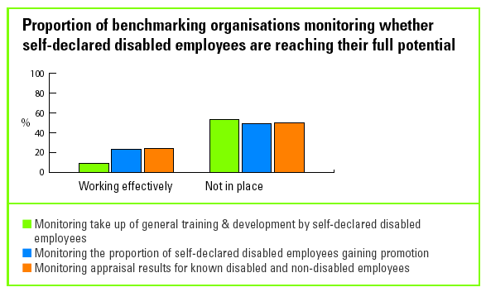

Monitoring employee support

Reasonable adjustments are monitored by one in three

30% of respondents report that they respond to requests for reasonable adjustments within 28 days and 34% have guidance and procedures for responding that work effectively.

A similar proportion - 33% - of respondents also report that they monitor the proportion of requests that they meet. 28% also keep an ongoing database of requests and responses to reasonable adjustments as a learning resource.

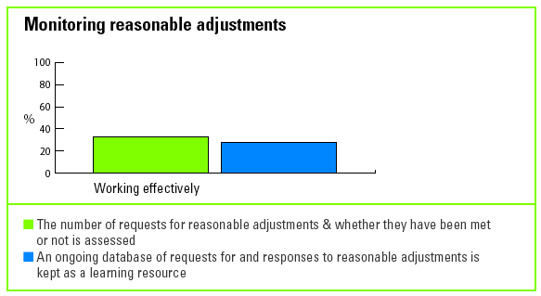

Absence levels are being monitored...

63% of respondents have effective mechanisms in place to monitor absence levels and the reasons for absence and use the results to inform future policy and practice.

...but organisations are failing to monitor progress in retaining their disabled employees

78% of respondents report that they have effective policies and procedures in place to help retain employees who become disabled. However, only 43% say they can monitor the impact of these procedures in practice.

36% of respondents report that they conduct exit interviews and record reasons for leaving which might be disability related. But only 15% say they effectively use the results of their exit interviews to help inform future policy and practice and that they compare results for disabled and non-disabled employees.

Monitoring cultures and behaviours

Only staff surveys and grievance procedures are being used to check disability
confident cultures and behaviours.

Mainstream staff surveys which invite employees to anonymously disclose whether they have a disability is the tool most often used by benchmarking organisations to check their cultures and behaviours.

44% of respondents report that their staff surveys are working effectively in this way. But 23% of respondents have yet to include the option of anonymously disclosing a disability in their staff surveys.

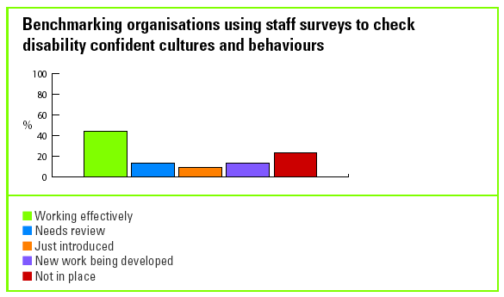

58% of respondents also report that they effectively monitor the number of complaints regarding disability harassment and discrimination and use the outcomes to inform future policy and practice.

Besides staff surveys and harassment complaints, few other mechanisms are used by benchmarking organisations to check whether what they are doing in order to develop disability confident cultures and behaviours is working.

Only 20% monitor the number of employees participating in disability awareness
training and 29% check the quality and impact of that training.

19% check whether disability confident messages communicated to employees are being heard and understood.

Checking levels of disability confident cultures and behaviours

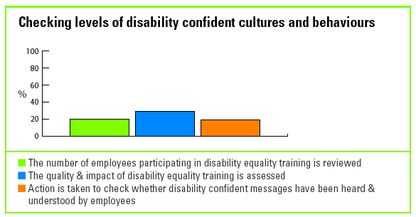

Results from the Act section of the Survey show that only 28% of benchmarking
organisations provide effective disability awareness training or have an effective
communications strategy to support their disability vision and goals.

It is therefore unsurprising that only 21% of participants report that their workforce understands how disability relates to their day-to-day jobs, with 20% confident that employees are committed to the organisation's vision for disability.

Reviewing the outcome of consultation with key disabled stakeholders

Results of consultation with disabled employees are being used to improve policies and procedures

84% of respondents are taking some action towards ensuring they use the results of consultation with their disabled employees to improve policies and procedures. Of these, 46% report that they do this effectively.

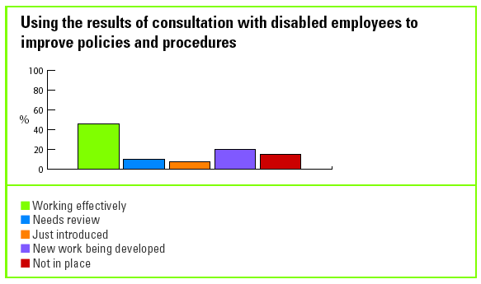

Complaints from disabled customers are being used to improve
service and product delivery

66% of respondents are taking action towards ensuring they use complaints from
customers to improve their service or product delivery. Of these, 45% report that they are already doing this effectively. However, this still leaves nearly a third of participants that have yet to take any action.

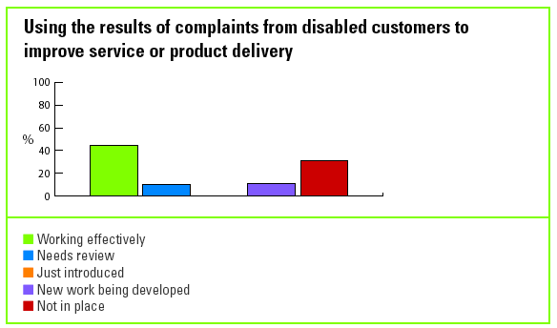

More work is needed to use feedback from disabled customers

28% of organisations which identify disabled customers in their satisfaction surveys report that they are using the results effectively to improve policies and procedures.

However, 49% of all respondents have yet to use the information - generated by
customers who inform them that they are disabled - in different relevant departments, e.g. service delivery, customer service, product/service development, IT, communications, training.

Reviewing the accessibility of products and services

Few organisations use the feedback they get from their disabled
Customers

53% of respondents are taking some action towards ensuring relevant departments use the results of market research with disabled people. Only 20% report that they are currently doing this effectively.

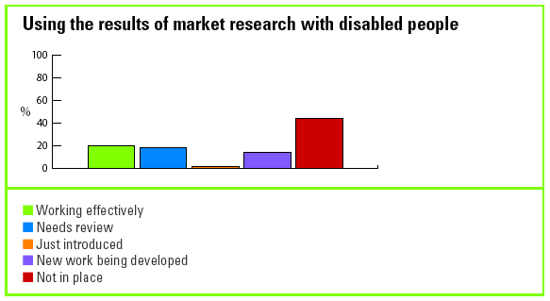

Although 50% of respondents say that they are effectively reviewing the accessibility of their products and services, only 34% act on the results of their product/service accessibility reviews to make the necessary improvements to design, policies, procedures and delivery.

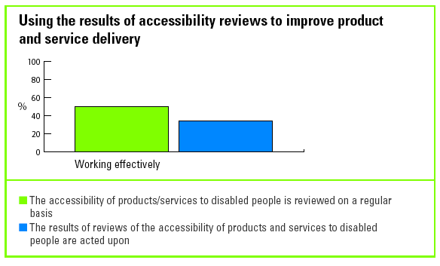

Reviewing the impact of disability confident actions on the organisation

Disability confident organisations need to engage the entire business

The Motivate section showed that 53% of respondents reported that their HR
departments have an action plan on disability and 55% have an action plan in their property services departments - but that 36% or less have developed action plans for disability in any other department.

The Impact results show that even when action plans have been set, relatively few organisations review whether the plans have been achieved. Only 45% review whether action plans are being implemented in HR; 43% review this in property services and only 20% review this in marketing.

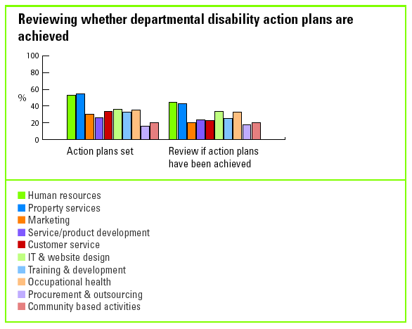

Few organisations capture the costs and benefits of becoming disability confident

Few benchmarking organisations assess either the costs of not being disability
confident or the benefits disability confidence can bring.

For example, 44% of respondents take no action to assess the cost to them of not getting it right on disability. 19% of respondents say that they do this effectively.

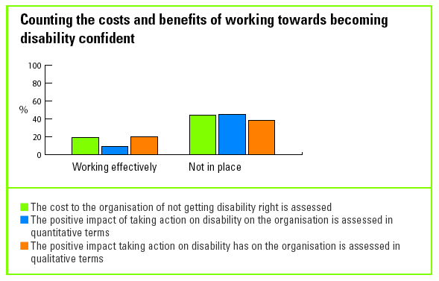

Impact: Good practice examples

Please summarise the impact of any initiatives you have taken to encourage disabled people to work within your organisation.

Motability Operations

We are currently building our own partnerships with organisations such as Remploy and are also exploring opportunities to use disability consultants to headhunt disabled applicants for senior positions.

We are launching our graduate recruitment campaign this year and we have selected certain universities due to their reputation for having strong disabled student networks e.g. UCL. Our diversity and disability confidence statements are an integral part of our recruitment website.

In a recent customer services recruitment campaign, we used a case study of a
disabled employee as the basis of a marketing campaign to generate interest in future roles within the organisation. It is difficult to measure the success of this campaign but we hope this has contributed towards building our brand as an employer of choice for disabled applicants.

What proportion of those eligible to attend recruitment and selection equality training in the past year have done so?

Royal Bank of Scotland

In terms of specific recruitment and selection equality training, by the end of 2004 119 Accredited Interview Training courses had been implemented and c.1080 managers had been Accredited. 189 courses are planned for 2005, expected to result in accreditation of a further 1700 interviewers. As previously mentioned, as well as this training all managers are required to complete online disability awareness training.

What success have you had in retaining employees who become disabled?

B&Q

As part of B&Q's attendance programme any DDA related absence is recorded separately and the focus is on what reasonable adjustment can be made to retain any employee. We use Access to Work regularly: around £30,000 was spent last financial year on equipment for disabled employees. A recent example was a General Manager who after several operations was having difficulty in writing. While this wasn't a problem in store, as he used someone to take notes, it was difficult when he attended meetings. We have provided him with a lightweight portable lap top to make notes and download into the system when he returns to the store. This has made it much easier for him to carry out his job.

The Victoria and Albert Museum

2003 - Employee A had a period of long term sick absence due to what was finally diagnosed as ME. He was eventually able to return on a very long term recuperative working pattern: his working hours were reduced and then gradually increased, and he was able to work from home occasionally. Responsibilities were reorganised to alleviate deadlines and pressure.

2002 - Employee B's problems with dyslexia only came to light when she was turned down for a supervisory role. The Museum recognised that she needed help and funded her for an extended programme of dyslexia assessment and training. Later an application was made to 'Access to Work' for special software to assist in the administrative work on the office computer.

2005 - Employee D who is registered blind has been provided with equipment to help him read.

Numerous employees with back or WRULD problems have been provided with equipment, including adjustable chairs, specialist keyboards and other IT equipment or software, such as work pacing, and on some occasions 'hands-free' voice-operated technology (though in our experience this had limited success).

The V&A appreciates that workplace adjustments are often not purely physical in nature. Clinically-recognised mental health problems such as clinical depression and/or serious anxiety states occur regularly in our workforce, as elsewhere.

We have often found that the most important adjustments are ensuring working hours are built up gradually following return from sick leave; ensuring that line managers understand the impact of the health condition on the employee personally and on their work capacities; and ensuring that there is readily available and supportive line management once someone is back at work.

The Museum's Welfare Service is available to everyone and usually provides employees with emotional and personal support during sickness absence, during their transition back into work and beyond, if the employee wants it.

What proportion of your requests for reasonable adjustments over the past year were acted upon within 28 days?

Royal Bank of Scotland

The Group has endeavoured to ensure that all requests are acted upon within an
appropriate timescale. In 2004 the process for requesting reasonable adjustments was reviewed and a workplace adjustments group was created which meets on a monthly basis to monitor and review progress on all cases highlighted as requiring reasonable adjustments. This has proved successful in ensuring that appropriate time scales are set and agreed with the employee.

What positive results have you had from your actions to build disability confident cultures and behaviours?

BT

Building in accessibility into all our internal communications such as subtitling all
webcasts and group videos has led to increased awareness so that disability is
embraced as part of our business as usual with an understanding of our disabled customer needs.

Lehman Brothers

- We have seen an increase in disabled candidates applying to the firm
- We have excellent qualitative feedback from both partners and disabled candidates on how their general perception of investment banking has improved - e.g. breadth of jobs available, welcoming/supportive culture, commitment to helping people find life balance.
- Recruiting managers are now less anxious about how to approach a candidate/employee with a disability
- Staff in general are better educated about the wealth of untapped experience that is available
- Managers feel that in some cases they have improved their management skills - e.g. interviewing a lady with Asperger's Syndrome made them think through their questions and general interview style.

Royal Mail

Our employee opinion survey results, from November 2003 and May 2004, show a 10% increase in our employees who consider themselves to have a disability being treated fairly, and a 53% increase in disabled employees wishing to be working for us in 12 0months time.

These results show that our disabled employees believe that a positive culture change has occurred and have changed their view of our organisation.

We have also worked with Mencap, Remploy and Scope to recruit disabled people.

Nationwide

We have noticed that teams working with a disabled employee are often stronger and closer as a result of working together to help support their colleague.

One particular example involves a young man with Asperger's Syndrome. When he came to Nationwide he had a vocabulary of 29 words and limited communication skills; nevertheless his new colleagues soon recognised his abilities and were keen to support him. They found ways of communicating. They celebrated each personal achievement and were jubilant when they were able to send him on errands which required him to initiate conversations. We also arranged for a chartered psychologist to train the team to support the employee and everyone ensured they could attend.

With increased numbers of disabled people now working for Nationwide, we find that disabled people themselves now feel able to be more honest about the difficulties they face. It is not uncommon to see disabled people here, and non-disabled employees seem less likely to have concerns about a disabled person joining their team.

What changes have been made as a result of your consultations with disabled stakeholders?

Lehman Brothers

- We purchased portable loops
- We now use larger fonts in presentations and ask people before the event if they would like specially prepared material. We also know to speak slower and indicate if we are changing slides
- We have a global team working on achieving accessibility for our website.
- We changed the timing of the door swipe to allow people to gain access before they lock into position
- We developed our evacuation policy and process to include a buddy for disabled employees
- We formed a technology accommodations team to manage all technical reasonable adjustment requests.

What improvements have been made to service delivery as a result of customer consultations?

Leicestershire Constabulary

The following changes have been made after consultation with disabled members of the public:
- entrance signs for people with learning difficulties
- all events have a question regarding access needs as part of the initial information, so we are informed of any necessary adjustments
- passwords for when we visit elderly people/disabled people with a visual impairment
- accessible parking bays at each police station
- taps in accessible toilets have a lever arch rather than a twist tap
- regular maintenance of shrubs etc, which at times can obscure/obstruct pathways, lighting etc
- automatic doors at entrance of most buildings
- induction loops installed
- customer care kits offered
- accessible notice board and information holders
- use of pictogram signage.

What indicators do you use to assess the impact disability action has had on your organisation?

Department for Work and Pensions

- Monitoring of complaints from the public in respect of access to premises and facilities.
- Surveys of staff awaiting reasonable adjustments and taking action to resolve outstanding Estates-related issues.
- Monitoring of service provider performance through PRIME Contract performance indicators.
- Monitoring of Occupational Health Assessment referrals, quality of referrals and speed of clearance.
- Audit of Services.
- DDA Internal Audit Report.
- Staff survey.
- Monitoring of Attendance Management.
- Mystery Shopping and customer surveys, complaints and praise.
- "Have your say" feedback on the Intranet.
- On-line feedback from Intranet on the disability pages of the Diversity and Equality site.
- Feedback from Disability Staff Network groups.
- Performance against goals and targets, including Cabinet Office and DWP aspirational targets on the number of disabled employees, by grade.
- Audit of reasonable adjustments support to staff.

Can you describe the positive impact disability action has had on your organisation generally?

The Victoria and Albert Museum

Visitors feel that service provision in the V&A has improved:

The Autumn 2004 Mori survey found that of those visitors whose health affects visits to museums and galleries, 50% agreed that the V&A provides an appropriate level of service regarding ease of access around the galleries (18% neither agree or disagree, 20 disagreed, 9% no opinion). This compares well to the results for the same period the year before, where only 24% agreed and 34% disagreed.

Similarly, provision for those with hearing difficulties was shown to have improved with 18% agreeing that the provision was appropriate (10% neither agreed nor disagreed, 0% disagreed and 72% no opinion), compared to 0% the year before (7% neither agreed nor disagreed, 5% disagreed, 88% no opinion). Visibility has also improved - in 2003, 31% disagreed that the lighting provision was appropriate, but in 2004, only 7% disagreed.

When diversity isn’t...

Disability is not on the diversity radar screen

Disability is not on the diversity radar screen…

A comparison of key questions across three benchmarks on race, gender and disability reveals disability to be the 'Diversity Cinderella'. It shows organisations struggling to manage disability as a diversity priority before they have the basic equal opportunities foundations in place.

Validated benchmarking services are provided by Opportunity Now1, Race for
Opportunity2 as well as the Employers' Forum on Disability.

Of the 80 organisations that participated in the Disability Standard Benchmark Survey, 26 also benchmarked their performance on race and gender over the past year.

In this section we compare the trends emerging from these three surveys. Please note that we can only comment on trends in the results of 15 very similar questions that were asked in each of the surveys. We cannot make direct comparisons because only 26 organisations participated in each of the three surveys, and the 15 questions, while very similar, were not worded in exactly the same way.

It is also important to note that when we refer to resources this does not include
making premises accessible. Nonetheless we are able, for the very first time, to
compare performance on disability to that of race and gender in some crucial areas, such as senior management commitment, investment of resources, shared accountability and assessing the impact of action on the organisation.

Despite the caution that should be applied to this comparison, the results make
interesting reading. Disability is beyond any doubt the poor diversity relation. There is more commitment by UK benchmarking organisations to race and gender and they are assigning more resources to race and gender than to disability. They are taking more action to ensure equality in employment for race and gender than for disability and finally, these organisations also appear to be more concerned about their public image on race and gender than on disability.

1 Opportunity Now is a business-led campaign that works with employers to realise the full potential of women at all levels and in all sectors of the workforce.

2 Race for Opportunity is an employers’ organisation that works with business to
demonstrate the clear opportunity business case for working on race in the UK environment and globally.

How do levels of organisational commitment to disability, race and gender compare?

Comparisons show higher levels of organisational commitment first to race, then
gender, and only then disability. This is demonstrated by:

- More organisations benchmarking their performance on gender and race than disability over the past year.

Number of organisations benchmarking their performance on diversity

Gender | Race | Disability
175 | 113 | 80

- Most organisations have policies to support race and gender equality, while less than half have policies to support disability equality.

Percentage of organisations that have policies to support race, gender and disability equality

Gender | Race | Disability
74% | 89% | 43%

- More organisations setting goals for race and gender equality than disability equality

Percentage of organisations that set race, gender and disability equality goals

Gender | Race | Disability
63% | 85% | 48%

- There is a high level of Board room commitment and responsibility for each of the diversity issues, but least for disability.

Percentage of organisations with Board level commitment to and responsibility for diversity

Gender | Race | Disability
81% | 94% | 70%

- Many more organisations include progress on race in their managers' performance appraisal process than do on gender, with very few measuring managers' contribution to achieving disability goals.

Percentage of organisations that assess managers' contribution to achieving race, gender or disability goals in their performance appraisal process

Gender | Race | Disability
26% | 64% | 14%

- Many organisations now have teams to help lead and guide their diversity work – but fewer have teams that consider disability.

Percentage of organisations with a team or department that leads and guides their diversity work

Gender | Race | Disability
85% | 88% | 73%

- Organisations invest significantly less in disability confidence than in race and gender.

Percentage of organisations with a budget for achieving their diversity goals

Gender | Race | Disability
68% | 90% | 48%

Do organisations recognise the value of disability, race and gender to their organisations?

- Although almost every benchmarking organisation has made a clear business case for race, fewer have done so for gender and fewer still for disability.

Percentage of organisations that have made a business case for race, gender or disability

Gender | Race | Disability
65% | 91% | 46%

Very few benchmarking organisations assess the impact of their disability actions on their organisation's overall performance compared with those that review their return on investment in race and gender.

Percentage of benchmarkers that assess the impact of their race, gender or disability actions on their organisation

Gender | Race | Disability
69% | 93% | 15%

What action is being taken to promote equality in employment?

- Most training to ensure equality in recruitment and selection is provided on race, followed by gender, and then disability.

Training provided to ensure equality in the recruitment and selection process

Gender | Race | Disability
66% | 76% | 56%

- Comparatively few benchmarking organisations monitor the number of job applications they receive from disabled people, compared to those that monitor gender and race.

Monitoring job applications by race, gender and disability

Gender | Race | Disability
68% | 85% | 49%

- Almost no benchmarking organisations monitor the number of disabled staff who take up training and development, compared with nearly half that monitor this for gender and nearly three quarters for race.

Monitoring the take-up of general training and development by race, gender and disability

Gender | Race | Disability
44% | 74% | 9%

- Just under a quarter compare the appraisal results for disabled and non-disabled staff; more do this on gender and most compare results by ethnic origin.

Monitoring appraisal results by race, gender and disability

Gender | Race | Disability
43% | 70% | 24%

- One way to assess if an organisations' equality and diversity goals are supported by employee behaviour is to track grievances and complaints of harassment and bullying. Just over half benchmarking organisations monitor disability related complaints compared with around three quarters that monitor this on race and on gender.

Tracking grievances and harassment or bullying complaints on race, gender and disability

Gender | Race | Disability
82% | 78% | 58%

- Most benchmarking organisations consult their employees on how race affects their experience in the workplace; only around half consult on gender and only 44% on disability.

Consulting employees on how race, gender and disability affect their experience in the workplace

Gender | Race | Disability
53% | 82% | 44%

Do organisations consider race, gender and disability in their marketing materials and external publications?

- The messages and images used in external publications and marketing speak volumes to the public of the importance an organisation places on equality and diversity.

- Although most benchmarking organisations are thinking about race or gender in the images and messages they use, only just over a third think about disability.

Considering race, gender and disability in externally communicated images and publications

Gender | Race | Disability
77% | 94% | 38%

Conclusions

In considering the trends on race, gender and disability it is important to bear in mind that Race for Opportunity and Opportunity Now have both been running their benchmarks for several years. This may have contributed to the higher scores achieved by those organisations as they build on their results to improve their performance year on year.

This is, of course, the first year of disability benchmarking. Nevertheless, there is every indication that for many organisations, diversity still does not include disability. Indeed, one would have to ask if, for many, disability is even positioned as an equal opportunities priority.

The Employers’ Forum on Disability would like to thank Opportunity Now and Race for Opportunity for their willingness to share their data and their help with making this comparison.

Results highlights

There is an important difference in how disability legislation affects the public and
private sectors as only the public sector will have a duty to promote disability equality. From December 2006 the public sector must ensure that its policies, service delivery and the way it carries out its public functions do not disadvantage or have a less favourable impact on disabled people. Many public sector organisations are also required to produce a Disability Equality Scheme.

Despite the differences, the sectors have much to learn from each other. Here we highlight where each of the sectors lead in the actions they are taking on disability and the results achieved.

 | Motivate | Act | Impact | Total
Private | 61% | 61% | 42% | 55%
Public | 60% | 68% | 49% | 59%

Overall the public and private sectors scores are broadly similar, with the public sector slightly leading. The most notable differences in performance between the sectors are summarised below.

The public sector is leading practice on:

- setting a disability vision and goals
- ensuring that recruitment and selection is free from bias and discrimination, welcomes disabled applicants and monitors their progress developing disability confident behaviours and cultures through training
- consulting with disabled employees
- monitoring the development of disabled employees.

The private sector is leading practice on:

- policies and standards which ensure disability equality in employment and service provision
- setting disability action plans in departments - beyond human resources and property services
- developing an economic and ethical case for disability
- reviewing responses to reasonable adjustments.

Public and private sectors compared

Results highlights

Motivate

Breakdown of results

Act
Breakdown of results

Impact
Breakdown of results

The public sector is working towards meeting its duty to
promote disability equality...

Many public sector respondents are preparing for the forthcoming legislative duty to promote disability. For example:
- 49% report that all external facing employees are aware of their legal obligations in delivering services and carrying out functions.
- 41% have procedures in place for working with other public bodies - although only 24% review the effectiveness of these procedures.

...but more needs to be done

Much more needs to be done if this sector is to meet its legal requirements as a basis for best practice:

- 24% have effective plans in place to prepare a Disability Equality Scheme and a further 64% are working towards this.
- 17% carry out effective research to establish the extent to which disabled people are accessing their services and 39% have yet to take any action on this.
- 37% review the way public functions are carried out and services are delivered and the impact they have on disabled people: 20% have done nothing on this.

The public sector results do imply that more guidance may be needed on how they should consult with disabled members of the public to ascertain the extent to which they are accessing services and how they are affected by public functions and policies.

Motivate: Breakdown of results

 | Public sector % | Private sector %
Motivate section total | 60 | 61
Identify vision & goals | 62 | 61
Establish policies & standards | 63 | 69
Establish strategy links & an economic &  ethical case for disability | 51 | 57
Establish management commitment & accountability | 61 | 59
Establish resources & a management structure | 60 | 61

Public sector leads on setting vision and goals

- The public sector is leading the way in setting a disability vision and goals and allocating resources.

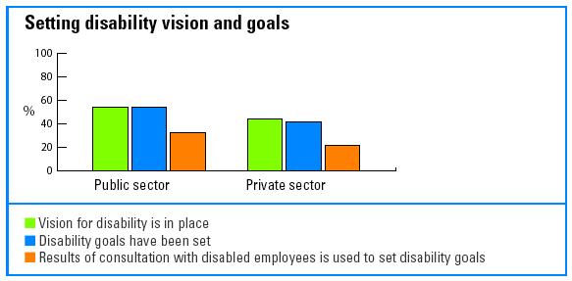

The private sector leads on putting policies and standards in place

More private sector companies than public sector organisations have put policies and standards in place to ensure disability equality will be achieved in employment and service provision.

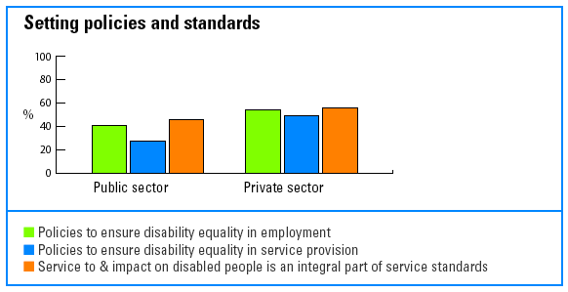

The private sector is leading on mainstreaming disability

The private sector is also further ahead in ensuring that disability actions are
embedded across their organisations beyond human resources and property.

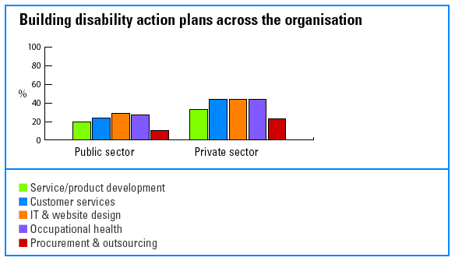

The economic and ethical case for disability is clear in more private sector companies

Almost twice as many private sector respondents (62%) than public sector respondents (32%) have made an economic and ethical case for addressing disability.

Although a further 47% of public sector respondents are working on their business case, this leaves 20% that have taken no action on this, compared to only 8% of private sector respondents.

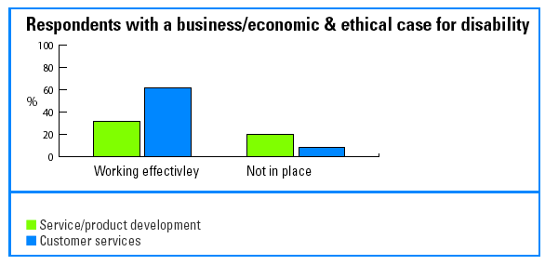

There is more senior management support for valuing disabled service users in the private sector

Only 49% of public sector respondents have senior management that have made a clear public commitment to valuing disabled people as service users compared to 72% in the private sector.

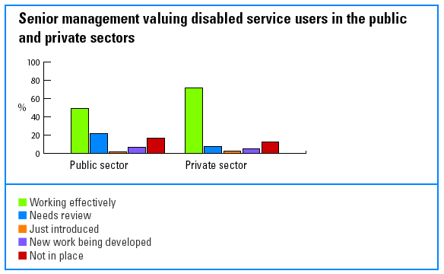

The public sector is in the early stages of preparing for their 'duty to promote' disability

At the heart of the duty to promote disability equality is the requirement that disabled service users and members of the public are not disadvantaged by the way in which policies or services are delivered.

Yet only 20% of public sector respondents use the results of reviews of the impact of their policies and actions on disabled people and only 17% use the results of research on the extent to which disabled people are accessing their services to help shape their disability goals and action plans.

Act: Breakdown of results

 | Public sector % | Private sector %
Act section total | 68 | 61
Recruitment & selection | 78 | 66
Training & development, promotion, appraisal & pay | 71 | 61
Work, workplace design & employee support | 80 | 77
Behaviours & cultures | 60 | 55
Involving & communicating with key stakeholders | 66 | 55
Accessibility of products & services | 54 | 52

The public sector shows strong commitment to recruiting disabled employees

More public sector than private sector organisations have taken steps to ensure their recruitment and selection process is open and welcoming to disabled applicants:

- 14% more public sector organisations than private sector offer adjustments to candidates at every stage of the recruitment process.
- 19% more public sector organisations than private sector companies inform managers that government assistance (Access to Work) is available should a disabled applicant require adjustments to do the job.
- 30% more public sector than private sector companies provide disability equality training for everyone involved with recruitment.

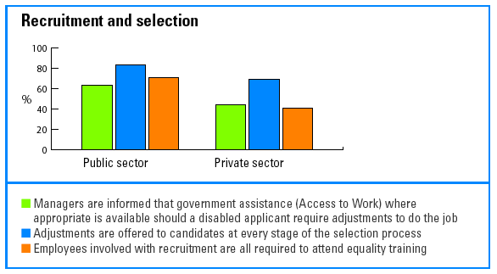

Also, more public than private sector respondents take positive action to recruit and develop disabled employees:

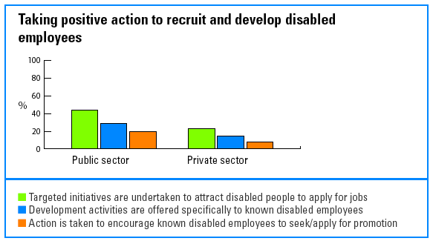

The public sector is more likely to invest in building the necessary behaviours and cultures

37% of public sector respondents compared to 18% of the private sector report that they have effective training programmes in place for all employees to support the achievement of their disability goals.

The public sector takes important steps to communicate with and involve disabled stakeholders

The public sector appears to be further ahead in consulting with their known disabled employees on their experiences of working in their organisations - 56% do this compared with 26% of the private sector.

The public sector is also making more progress in consulting with known disabled service users and members of the public on their satisfaction with services. However, very few from either sector do this - 29% of the public sector compared with 13% of the private sector.

More public (49%) than private (26%) sector respondents have also taken action to ensure their literature and campaigns include positive images of disabled people.
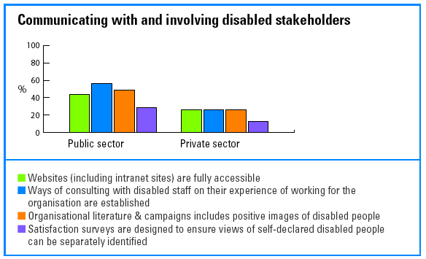

The public sector still has a long way to go to ensure accessible services

Public sector benchmarking respondents are clearly working on meeting legislative requirements:

- 49% of respondents report that all external facing employees are aware of their legal obligations in delivering services and carrying out functions.
- 41% of respondents say they have procedures for working with other public bodies to ensure disabled people are not discriminated against or treated less favourably when carrying out public functions and delivering services - and that these are working effectively.

However,

- Only 17% of public sector respondents carry out effective research to establish the extent to which disabled people are accessing their services. 39% have yet to take any action on this issue.

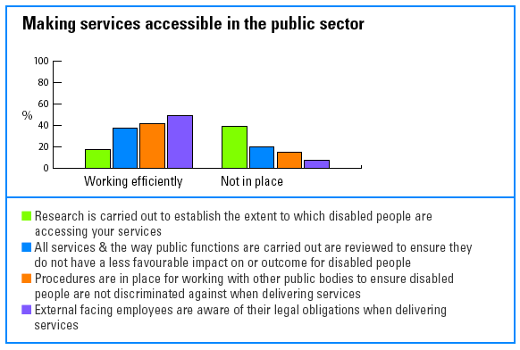

Impact: Breakdown of results

 | Public sector % | Private sector %
Impact section total | 49 | 42
Monitor recruitment & selection | 69 | 44
Assess & review training & development, promotion, appraisal & pay | 42 | 21
Research work, workplace design & employee support | 50 | 48
Assess & review behaviours & cultures | 50 | 44
Assess & review the results of consultation  with key stakeholders | 46 | 49
Assess & review the accessibility of products & services | 46 | 40
Assess & review the impact of action on the organisation | 40 | 45

The public sector has scored slightly higher overall than the private sector in assessing the impact of what it does to become disability confident.

It is significantly ahead in monitoring the recruitment, selection and development of disabled employees. However, in all other areas both the public and private sector have much to do if they are to assess progress in ensuring products and services are accessible and that their behaviours and cultures support disability confidence.

Private sector companies are slow to monitor disability in recruitment and selection

- 33% of private sector respondents can monitor how many self-declared disabled applicants they appoint, compared to 78% of public sector respondents.
- 23% of private sector respondents can monitor how many disabled applicants they attract or interview compared with 73% of the public sector that monitor the number of disabled people applying for jobs and 68% that monitor the number being interviewed.

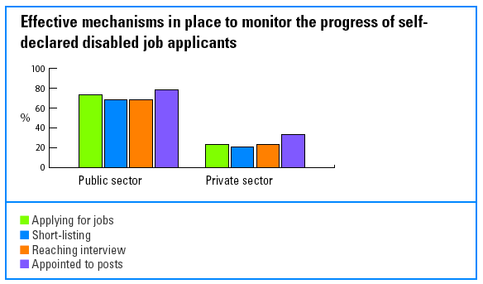

The private sector is falling behind in ensuring disabled
employees reach their full potential

Only 9% of all respondents effectively monitor the take up of general training and
development by self-declared disabled employees. However, 54% of the public sector is working on this, compared to 21% of the private sector.

In addition, 34% of public sector respondents effectively compare promotion results between self-declared disabled and non-disabled employees and 37% can do this for appraisal results. Only 10% of private sector respondents are doing this.

Moreover, 77% of private sector respondents have yet to take any action on this issue compared with 24% of the public sector in this position.

More private sector companies track their performance in responding to requests for reasonable adjustments

38% of private sector respondents effectively monitor how many requests for
reasonable adjustments are met, compared with 27% of the public sector.

33% of private sector respondents keep a database of requests for and responses to reasonable adjustments as a learning resource, compared with 22% of the public sector.

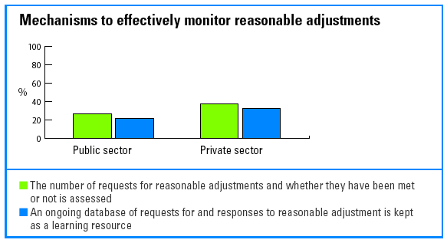

The public sector more likely to assess progress in developing disability confident cultures and behaviours

More public sector (51%) than private sector respondents (36%) are using staff surveys that invite employees to anonymously disclose whether they have a disability, to check disability confidence in cultures and behaviours.

More public sector than private sector respondents are also taking action to ensure that most employees understand how disability relates to their day-to-day jobs. 66% of the public sector are taking action on this compared to 49% of the private sector. Notably, only 21% across both sectors actually do this effectively.
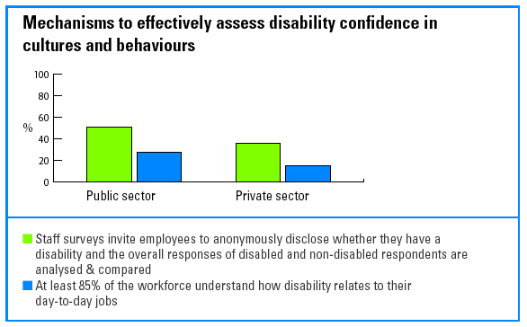

Results of consultation with disabled stakeholders are being used to improve performance

There would seem to be much learning to share between the public and private sectors regarding how to use the results of consultation with disabled stakeholders:

- 54% of public sector respondents use the results of consultations with their employees to improve policies, procedures and actions, compared with 38% of the private sector.
- 32% of public sector respondents use the results of service user satisfaction surveys to improve policies, procedures and actions compared to 23% of the private sector.
- Conversely, 54% of private sector respondents effectively review information from disabled customer complaints and from customers who self-disclose to help inform policy, practice and product/service delivery compared with 37% of public sector respondents.

More work is needed to monitor the accessibility of public services

The survey shows that much more needs to be done by the public sector in reviewing service provision and accessibility of services:

- 24% of public sector respondents review the effectiveness of their procedures for working with other public authorities to ensure disability equality. 49% have yet to do so.
- 34% of the public sector effectively review the way public functions are carried out and the impact they have on disabled people in order to make improvements to policy, procedures and actions. A further 24% have yet to do so.
- 29% of public sector respondents know the proportion of disabled people who are eligible, yet who do not yet access their services and then use this information to develop action plans to remedy this. A further 37% have yet to take action on this.

Conclusions and recommendations

Conclusions

Recommendations

Conclusions

Despite the diversity of participants and the wide range of scores, there are a number of significant trends.

Disability lags behind race and gender

For the first time we can compare performance on disability with that on race and
gender. We are grateful to Race for Opportunity and Opportunity Now for sharing their data.

Comparisons across the 26 organisations which have now benchmarked on race, gender and disability show that disability is the poor relation.

Organisations do less and spend less on disability compared with their investment in race and gender. This pattern is even true for those companies that are outstanding in their commitment to self-improvement across all three diversity strands.

- 90% of organisations have an allocated budget to support race equality compared to just 48% on disability.
- 89% have policies to support race equality, 74% have policies to support gender equality while just 43% have policies to support disability equality.
- 93% assess impact of actions on race; 15% assess impact of actions on disability.

It would seem disability and disability discrimination are still regarded as distinctly
different from - and less important than - race and gender. Discrimination legislation is not having the impact which some might have anticipated.

Our results suggest that many organisations have yet to understand that they are
required to treat people differently in order to treat them fairly and that to discriminate on grounds of disability is fundamentally no different from discrimination on grounds of race or gender.

The Employers' Forum will be inviting stakeholders concerned with disability, race, gender, age, sexual orientation and belief to consider the implications of these findings on plans to create the single equality body: the Commission for Equality and Human Rights.

Commitment at the top is not enough

While business leaders and those at the top of organisations tend to be genuinely committed, they are failing to communicate that commitment and are not tackling culture change.

- 79% of organisations have a stated commitment to disability, and 70% take responsibility for disability equality at Board level.
- But only 48% have set disability equality goals and just 46% have established the business and ethical case for their organisation to take action.
- What's more, only 28% are training their employees to become disability confident.

The public sector needs to focus on service users

The public sector has scored slightly better than the private sector overall but the findings show that the public sector has much further to go in making its services accessible.

- Just 27% of the public sector design their market/service user research so that the specific needs and preferences of disabled people can be separately assessed.
- 49% of the public sector has senior management publicly committed to valuing disabled people as service users - that number is 72% for the private sector.
- 34% effectively monitor the impact of what they do on disabled people in the wider community.
- Just 17% effectively research the extent to which disabled people access their service.

Given the new duty to promote disability equality in everything they do, the public
sector will need to focus in particular on improving its capacity to value and consult service users with disabilities.

We know that legislation can make a difference and that employers can find ways to comply. The DDA has ensured, for example, that 75% of respondents are now confident their built environment is fully accessible or have a schedule for improvements to make it so.

The public sector is leading the way in setting a disability vision, developing 'disability confident' behaviours and cultures through training, and consulting with disabled people. But it is the private sector that is leading in putting the policies and standards in place to support disability in employment and service provision; inter-departmental action planning; and developing a business and ethical case for disability.

Recommendations

What does this mean for your organisation?

Those who scored above 75% demonstrate what can be achieved by 'disability confident' organisations. It is possible to:

- make disability - and the need to become disability confident - a business priority
- measure the impact of your diversity strategy by the impact you are having on people with disabilities and your capacity to become 'disability confident'
- ensure that your diversity strategy eliminates those particular attitudinal, policy and procedural barriers which prevent equality for disabled people
- help board-level champions to become 'disability confident' as individuals and to help make disability a priority.

What we learn from the best?

There is a significant and surprising gap between the top and bottom scores. The
average overall score for those in the top 10% is 89%: for those in the bottom 10% it is just 24%.

Organisations in the top 20% show that disability is integral to the way they now do business. A few organisations, from both the public and private sector, have scored very well indeed. They are equipped and motivated and would seem well-placed to recruit, retain and develop many more disabled employees and to deliver high quality services to disabled customers.

Meanwhile, those who scored below 25% are particularly vulnerable to legal and
reputational risk. Employers have been required to make adjustments for people with disabilities in the workplace since 1995, yet only 34% have the necessary policies and procedures, and only 30% can respond to requests for adjustments in less than 28 days - a prudent response standard.

Eighteen organisations scored over 75% in the survey. This includes 11 public organisations and six companies from the FTSE 100. These high performers have much in common:

1) They have developed a shared commitment and accountability

The top 18 have all set specific disability goals linked to the results of internal and external monitoring and have a clear business rationale for working on disability.
Their senior management have clearly stated their commitment to valuing disabled people both as employees and customers and their Boards take overall responsibility for becoming disability confident. Every top performing organisation has individuals or teams working effectively to help direct them towards disability confidence.

Fifteen of the top 18 are also building disability into every manager's performance goals and appraisal process and have set action plans with assigned resources across every business area.

2) They build strong policy and procedure foundations

The top 18 all have policies to support disability in employment and product/service provision and are putting reasonable adjustment policies and procedures in place. They ensure that their recruitment and selection as well as their development processes do not discriminate against disabled employees. They also have procedures to retain employees who become disabled. Their premises are barrier free and they have action plans to help build a healthy workplace.

3) They focus on changing culture and behaviours

For the top 18, disability is more than accessible premises and/or policies; they also understand the importance of developing disability confident behaviours and organisational cultures. Their disability training covers the organisation's legal obligations and policy expectations; the business and ethical case for disability, and the need to challenge assumptions and change behaviour. It also includes any specialist information relevant to those being trained.

They each have a disability communications’ strategy to help build greater understanding of and support for the organisation's commitment to becoming disability confident. They also all publicise their disability achievements internally and externally.

4) They talk to disabled people

Every organisation in the top 18 makes sure that all their information – including websites - is provided in accessible formats. They consult with their disabled staff on their experience of working in their organisation; 15 are taking action to ensure the views of disabled people can be identified in customer satisfaction surveys.

5) They make products and services accessible

Every leading organisation is working to make its products and services accessible by including the needs of disabled people in the design brief and reviewing accessibility regularly.

Seventeen are working towards ensuring that all their providers of outsourced services can demonstrate they are working to the spirit of disability legislation.

Each of the top 11 public sector organisations is researching the extent to which disabled people are accessing their services and that they are ensuring that their practices do not have a less favourable impact on disabled people.

They also work with other public bodies to ensure that every external facing employee is aware of the organisation's legal obligations in carrying out public functions.

What next for your organisation?

The Employers' Forum Disability Standard makes it easier to turn your commitment into real business improvement.

Plan ahead to be part of the next Standard Survey, and access the confidential report, the seminars, Forum advice and the Standard Directory which serves as your navigational guide through the complex world of regulation, legislation and definitive guidance as well as the learning network of organisations involved.

And remember: attitudes and behaviours will only change when the organisation engages directly with disabled individuals in a way that builds relationships and mutual understanding.

How can you improve your performance on disability?

Position disability as a diversity priority

- Position disability as a business priority in all diversity-related communications.
- Measure the impact of any diversity strategy by the impact you are having on people with disabilities.
- Ensure any diversity strategy has eliminated those attitudinal, policy and procedural barriers which prevent disabled people from gaining equal access as employees and customers.
- Remember: attitudes and behaviours will only change when the organisation engages directly with disabled individuals in a way that builds relationships and mutual understanding.

Get the motivation right

- Build a business, economic and ethical case for disability and communicate this to every employee through a combination of disability-specific training and mainstream communications.
- Make managers accountable for achieving progress by building disability into their performance objectives and the appraisal process.
- Spread accountability for disability by setting action plans across all areas of your business and by asking Board level champions to report on impact to the Board, and to communicate the rationale for disability confidence.

Be seen to mean it

- Put policies and standards in place to support disability in employment and the delivery of products and services.
- Communicate your commitment, plans and progress on disability - map out the journey for employees and customers.

Focus on outcomes

- Create a vision for what your organisation will look and feel like once you are disability confident.
- Always ask early in the planning process: 'how are we going to measure our performance on this disability action?'
- Mainstream disability into all your monitoring and reviewing processes (training attendance, promotion and appraisal results; satisfaction surveys etc).

Learn from each other

- Share best practice with other organisations.
- Share experiences of what has worked and not worked and why, both internally and externally.
- Commit to benchmarking with other organisations and use the results to improve performance.

Make it easier on your colleagues

Colleagues need to know where to go for guidance about best practice and what your organisation expects from them. Tell them:

- who can answer questions related to the DDA and your policies and expectations
- who can help managers find solutions on a day to day basis, e.g. via an in-house helpline or linked to the Employers' Forum
- who monitors progress and spreads success
- who co-ordinates moving into action
- who communicates disability performance to the Board.

Build the skills and competencies you need

- Focus on attitudes and behaviours - help people understand how disability discrimination is experienced.
- Overcome fear and stereotyping and build personal skills and confidence through training, communication and events which facilitate personal contact between colleagues and people with disabilities.
- Make sure employees know how to communicate in an accessible way with colleagues and customers.

Get closer to your disabled customers and service users

- Ensure your market research can identify the specific needs and preferences of disabled customers.
- Identify the nature of complaints coming from disabled customers.
- Build the needs of disabled people into the design brief for new products and services.
- Research the extent to which disabled people use your products and services.

Glossary, appendices and acknowledgments

Glossary

Appendix 1
Who responded to the Benchmark?

Appendix 2
Benchmarking results

Appendix 3
How the scores were calculated

Acknowledgments

Glossary

Behaviours and cultures

Behaviours refers to the way in which employees within an organisation conduct themselves and treat others - including their fellow employees; customers/service users and other stakeholders. Culture refers to the collective manifestation of these behaviours and the, often unspoken, common understanding of the way things are done.

Some indicators of cultures that not support disability can include:

- narrow assumptions about what the term covers - only wheelchair users or perhaps blind or deaf people may come to mind
- failing to see disabled people as individuals and focusing exclusively on impairments or diagnosis, in effect defining people solely by their disabilities. For example, an accountant who develops epilepsy becomes an 'epileptic' - her accountancy skills are disregarded
- a lack of understanding of the technical solutions that can now empower disabled people in work.

You will know that the behaviours and cultures in your organisation are beginning to develop to support disability when your employees:

- describe disability as a business issue
- expect to be treated fairly should they become disabled while working for the organisation
- expect to be valued for recruiting disabled people and making adjustments
- are able to describe the organisation plan/policy for disability and be able to explain this to customers and other stakeholders.

Business case

The economic, ethical and legal rationale for addressing disability as a priority for business and for becoming disability confident.

Customers

In this report, customers refer to the people who buy and/or use your products and your organisation's services. Other equivalent terms include service users or clients.

The specific legal framework for disabled customers should be noted. Part III of the Disability Discrimination Act 1995 makes it unlawful to discriminate against disabled people in the provision of goods, facilities and services whether charged for or free and the sale or letting of premises. This applies to every organisation, however, small and includes services provided by public authorities, charities, professional bodies, private agencies or individuals.

Since December 1996, it has been unlawful for service providers to treat disabled
people less favourably for a reason related to their disability. Since October 1999, service providers have had to make 'reasonable adjustments' for disabled people, e.g. by providing extra help, or by changing the way the service is provided. Also since October 1999, service providers must provide an alternative method of service where physical features of the premises make it impossible or unreasonably difficult to use the service. Since 2004, service providers have had to make 'reasonable adjustments' to the physical features of their premises to overcome physical barriers to access (see reasonable adjustment definition below).

Disability

The Disability Discrimination Act (DDA) 1995 definition of disability is, 'a physical or mental impairment which has a substantial and long-term adverse effect on a person's ability to carry out normal day-today activities'. For more information on the legal definition of disability, refer to the Disability Rights Commission publication, 'Definition of disability'.

Disability confidence

Disability confident employers will:

- naturally include disabled people as part of a truly diverse workforce
- view disabled customers as an important and increasingly significant market segment and disabled people, their friends, families and colleagues as important stakeholders
- see the old way of looking at disability - which often results in discrimination because assumptions are made regarding what disabled people can and cannot do - as no longer acceptable
- be skilled in making adjustments and be more responsive to the potential contribution of every employee
- focus on the capacity and potential of the individual and empower disabled individuals (and indeed everyone) to contribute by making reasonable adjustments and as a result gain genuine business benefit.

Disability equality

Ensuring that disabled people are treated fairly and according to their individual needs.

Disability Standard

The Disability Standard, a comprehensive management tool, comprises:

- A self-completed Benchmark Survey, which requires the organisation to provide evidence to justify its ratings. The Survey is independently validated and addresses all aspects of policies and procedures relating to employment, customer care, IT, the built environment, new product development, e-commerce and e-recruitment, corporate responsibility, procurement, health and safety, occupational health, marketing and communications, consultations with disabled stakeholders and staff, management training, and top team commitment.
- The Standard Directory, which links step-by-step to the Survey, lists all the relevant disability legislation, codes of practice, regulations, technical standards and best practice guidance from the Disability Rights Commission, the Forum and other recognised authorities.
- The Benchmark for Action Conference, at which overall results of the Survey and the key messages deduced from the results are fed back to the participating organisations. It is also an opportunity for organisations that took part to discuss their results with peers and share what works, what doesn't work, examples of best practice and barriers to improvement.

Diversity

Diversity should be the result of valuing and welcoming difference by ensuring equality of opportunity and therefore fair treatment for everyone. Treating people fairly does not mean treating everyone the same but rather treating people differently according to need.

Diversity policies and strategies set out how difference should be valued by organisations; how to ensure that people are not treated less favourably because of any difference and how to maximise the benefits of valuing difference for employees, customers/clients and the organisation.

Diverse organisations value difference and reflect the communities in which they serve.

Duty to promote

The public sector will, from 2006, have a legal duty to promote equality of opportunity for disabled people (disability equality). This means ensuring that their internal and external policies and the way in which they deliver their services and carry out public functions do not have an adverse impact on people with disabilities.

Reasonable adjustments

An employer has a duty under the DDA (1995) to make reasonable adjustments to prevent a disabled employee from being placed at a substantial disadvantage by any physical feature of the premises, or by any provision, criteria or practice of the employer. The duty applies to all aspects of employment, including recruitment and selection, training, transfer, career development and retention.

Service providers must make reasonable adjustments to the way in which their services are provided if disabled customers find it unreasonably difficult or impossible to use their services. This is an anticipatory duty.

In particular service providers may have to:

- change practices, policies or procedures
- provide auxiliary aids and services.

Where physical features of premises make it impossible or unreasonably difficult for a disabled person to use the service a service provider may have to:

- remove the feature
- alter the feature
- provide a reasonable means of avoiding it; or
- provide the service by reasonable alternative means.

Stakeholders

Everyone associated with or affected by your organisation. This includes: employees, customers, local communities, shareholders and subcontractors.

Appendix 1

Who responded to the Benchmark?

80 organisations responded to the benchmark. This includes:

- 39 private sector organisations
- 41 public sector organisations

Respondents represent organisations of different sizes.

Number of employees | Number of responding organisations
1 - 50 | 2
51 - 250 | 3
251 - 500 | 2
501 to 1,000 | 9
1,001 to 5,000 | 29
5,001 - 10,000 | 9
10,001 - 20,000 | 9
20,000 + | 17

Appendix 2

Benchmarking results

- Overall results

Average benchmarking scores

Motivate | Act | Impact | Total
61% | 65% | 45% | 57%

Motivate - average scores

 | Total %
Motivate section total | 61
Identify vision & goals | 61
Establish policies & standards | 66
Establish strategy links & a business & ethical case | 54
Establish management commitment & accountability | 60
Establish resources & a management structure | 61

Act - average scores

 | Total %
Act section total | 65
Recruitment & selection | 72
Training & development, promotion, appraisal & pay | 66
Work, workplace design & employee support | 79
Behaviours & cultures | 58
Involving & communicating with key stakeholders | 60
Accessibility of products & services | 53

Impact - average scores

 | Total %
Impact section total | 42
Monitor recruitment & selection | 57
Assess & review training & development, promotion, appraisal & pay | 32
Research work, workplace design & employee support | 49
Assess & review behaviours & cultures | 47
Assess & review the results of consultation with key stakeholders | 48
Assess & review the accessibility of products & services | 43
Assess & review the impact of action on the organisation | 43

- Public sector results

Average benchmarking scores

Motivate | Act | Impact | Total
60% | 68% | 49% | 59%

Motivate - average scores

 | Public Sector %
Motivate section total | 60
Identify vision & goals | 62
Establish policies & standards | 63
Establish strategy links & an economic & ethical case for disability | 51
Establish management commitment & accountability | 61
Establish resources & a management structure | 60

Act - average scores

Public
Sector %
Act section total | 68
Recruitment & selection | 78
Training & development, promotion, appraisal & pay | 71
Work, workplace design & employee support | 80
Behaviours & cultures | 60
Involving & communicating with key stakeholders | 66
Accessibility of products & services | 54
Impact - average scores

Public
Sector %
Impact section total | 49
Monitor recruitment & selection | 69
Assess & review training & development, promotion, appraisal & pay | 42
Research work, workplace design & employee support | 50
Assess & review behaviours & cultures | 50
Assess & review the results of consultation with key stakeholders | 46
Assess & review the accessibility of products & services | 46
Assess & review the impact of action on the organisation | 40

- Private sector results

Average benchmarking scores

Motivate | Act | Impact | Total
61% | 61% | 42% | 55%

Motivate - average scores

Private
Sector %
Motivate section total | 61
Identify vision & goals | 61
Establish policies & standards | 69
Establish strategy links & an economic & ethical case for disability | 57
Establish management commitment & accountability | 59
Establish resources & a management structure | 61

Act - average scores

Private
Sector %
Act section total | 61
Recruitment & selection | 66
Training & development, promotion, appraisal & pay | 61
Work, workplace design & employee support | 77
Behaviours & cultures | 55
Involving & communicating with key stakeholders | 55
Accessibility of products & services | 52

Impact - average scores

Private
Sector %
Impact section total | 42
Monitor recruitment & selection | 44
Assess & review training & development, promotion, appraisal & pay | 21
Research work, workplace design & employee support | 48
Assess & review behaviours & cultures | 44
Assess & review the results of consultation with key stakeholders | 49
Assess & review the accessibility of products & services | 40
Assess & review the impact of action on the organisation | 45

- Banking finance and insurance sector results

Average benchmarking scores

Motivate | Act | Impact | Total
74% | 72% | 53% | 66%

Motivate - average scores

 | Sector %
Motivate section total | 74
Identify vision & goals | 73
Establish policies & standards | 79
Establish strategy links & an economic & ethical case for disability | 76
Establish management commitment & accountability | 70
Establish resources & a management structure | 71

Act - average scores

 | Sector %
Act section total | 72
Recruitment & selection | 79
Training & development, promotion, appraisal & pay | 71
Work, workplace design & employee support | 88
Behaviours & cultures | 72
Involving & communicating with key stakeholders | 67
Accessibility of products & services | 54

Impact - average scores

 | Sector %
Impact section total | 53
Monitor recruitment & selection | 53
Assess & review training & development, promotion, appraisal & pay | 26
Research work, workplace design & employee support | 61
Assess & review behaviours & cultures | 56
Assess & review the results of consultation with key stakeholders | 68
Assess & review the accessibility of products & services | 44
Assess & review the impact of action on the organisation | 62

5. Commerce, trade and retailing sector results

Average benchmarking scores

Motivate | Act | Impact | Total
67% | 64% | 44% | 58%

Motivate - average scores

 | Sector %
Motivate section total | 67
Identify vision & goals | 63
Establish policies & standards | 68
Establish strategy links & an economic & ethical case for disability | 59
Establish management commitment & accountability | 63
Establish resources & a management structure | 83

Act - average scores

 | Sector %
Act section total | 64
Recruitment & selection | 72
Training & development, promotion, appraisal & pay | 71
Work, workplace design & employee support | 80
Behaviours & cultures | 57
Involving & communicating with key stakeholders | 53
Accessibility of products & services | 50

Impact - average scores

 | Sector %
Impact section total | 44
Monitor recruitment & selection | 63
Assess & review training & development, promotion, appraisal & pay | 26
Research work, workplace design & employee support | 36
Assess & review behaviours & cultures | 49
Assess & review the results of consultation with key stakeholders | 51
Assess & review the accessibility of products & services | 30
Assess & review the impact of action on the organisation | 45

6.Consultancy and professional sector results

Average benchmarking scores

Motivate | Act | Impact | Total
30% | 36% | 13% | 26%

Motivate - average scores

 | Sector %
Motivate section total | 30
Identify vision & goals | 32
Establish policies & standards | 40
Establish strategy links & an economic & ethical case for disability | 35
Establish management commitment & accountability | 28
Establish resources & a management structure | 13

Act - average scores

 | Sector %
Act section total | 36
Recruitment & selection | 44
Training & development, promotion, appraisal & pay | 37
Work, workplace design & employee support | 55
Behaviours & cultures | 23
Involving & communicating with key stakeholders | 26
Accessibility of products & services | 29

Impact - average scores

 | Sector %
Impact section total | 13
Monitor recruitment & selection | 28
Assess & review training & development, promotion, appraisal & pay | 0
Research work, workplace design & employee support | 13
Assess & review behaviours & cultures | 14
Assess & review the results of consultation with key stakeholders | 13
Assess & review the accessibility of products & services | 8
Assess & review the impact of action on the organisation | 18

7. Government central sector results

Average benchmarking scores

Motivate | Act | Impact | Total
57% | 69% | 50% | 58%

Motivate - average scores

 | Sector %
Motivate section total | 57
Identify vision & goals | 65
Establish policies & standards | 62
Establish strategy links & an economic & ethical case for disability | 38
Establish management commitment & accountability | 61
Establish resources & a management structure | 56

Act - average scores

 | Sector %
Act section total | 69
Recruitment & selection | 80
Training & development, promotion, appraisal & pay | 77
Work, workplace design & employee support | 78
Behaviours & cultures | 58
Involving & communicating with key stakeholders | 68
Accessibility of products & services | 54

Impact - average scores

 | Sector %
Impact section total | 50
Monitor recruitment & selection | 73
Assess & review training & development, promotion, appraisal & pay | 50
Research work, workplace design & employee support | 47
Assess & review behaviours & cultures | 47
Assess & review the results of consultation with key stakeholders | 48
Assess & review the accessibility of products & services | 49
Assess & review the impact of action on the organisation | 34

- Information and communication sector results

Average benchmarking scores

Motivate | Act | Impact | Total
58% | 58% | 37% | 51%

Motivate - average scores

 | Sector %
Motivate section total | 58
Identify vision & goals | 57
Establish policies & standards | 67
Establish strategy links & an economic & ethical case for disability | 50
Establish management commitment & accountability | 62
Establish resources & a management structure | 53

Act - average scores

 | Sector %
Act section total | 58
Recruitment & selection | 51
Training & development, promotion, appraisal & pay | 56
Work, workplace design & employee support | 74
Behaviours & cultures | 49
Involving & communicating with key stakeholders | 44
Accessibility of products & services | 71

Impact - average scores

 | Sector %
Impact section total | 37
Monitor recruitment & selection | 27
Assess & review training & development, promotion, appraisal & pay | 35
Research work, workplace design & employee support | 38
Assess & review behaviours & cultures | 33
Assess & review the results of consultation with key stakeholders | 31
Assess & review the accessibility of products & services | 58
Assess & review the impact of action on the organisation | 38

- Other public sector results

Average benchmarking scores

Motivate | Act | Impact | Total
66% | 77% | 62% | 68%

Motivate - average scores

 | Sector %
Motivate section total | 66
Identify vision & goals | 62
Establish policies & standards | 65
Establish strategy links & an economic & ethical case for disability | 61
Establish management commitment & accountability | 57
Establish resources & a management structure | 83

Act - average scores

 | Sector %
Act section total | 77
Recruitment & selection | 91
Training & development, promotion, appraisal & pay | 81
Work, workplace design & employee support | 84
Behaviours & cultures | 75
Involving & communicating with key stakeholders | 72
Accessibility of products & services | 58

Impact - average scores

 | Sector %
Impact section total | 62
Monitor recruitment & selection | 79
Assess & review training & development, promotion, appraisal & pay | 73
Research work, workplace design & employee support | 61
Assess & review behaviours & cultures | 65
Assess & review the results of consultation with key stakeholders | 47
Assess & review the accessibility of products & services | 56
Assess & review the impact of action on the organisation | 57

10. Police sector results

Average benchmarking scores

Motivate | Act | Impact | Total
48% | 53% | 29% | 43%

Motivate - average scores

 | Sector %
Motivate section total | 48
Identify vision & goals | 40
Establish policies & standards | 48
Establish strategy links & an economic & ethical case for disability | 42
Establish management commitment & accountability | 55
Establish resources & a management structure | 55

Act - average scores

 | Sector %
Act section total | 53
Recruitment & selection | 65
Training & development, promotion, appraisal & pay | 51
Work, workplace design & employee support | 76
Behaviours & cultures | 45
Involving & communicating with key stakeholders | 43
Accessibility of products & services | 37

Impact - average scores

 | Sector %
Impact section total | 29
Monitor recruitment & selection | 46
Assess & review training & development, promotion, appraisal & pay | 9
Research work, workplace design & employee support | 50
Assess & review behaviours & cultures | 31
Assess & review the results of consultation with key stakeholders | 24
Assess & review the accessibility of products & services | 20
Assess & review the impact of action on the organisation | 20

Appendix 3

How the scores were calculated

- Self-completion

The Disability Standard Benchmark Survey is self-completed by participants. A five point scale is used to establish the point of progress an organisation is at on each question within the survey. The scale reflects the journey many organisations travel through in developing disability equality.

2. The definitions of the ratings are:

Not in place

Nothing is in place or being considered on this.

New work being developed

No action has been taken on this before, but new work is now being designed or
tested.

Just introduced

New work has been introduced on this: it may be too early to assess its impact, or no assessment of impact has yet been made.

Needs review

An assessment of the impact of this is being/has been undertaken. Results show it is not working effectively, or only in some places. Work is now planned or underway to improve, change or expand so it becomes effective. This rating may be applied to something that has worked effectively in the past but is now failing to do so and requires significant change. For example, a policy may need re-writing, new procedures may need to be issued, a training programme may need to be re-designed etc.

Working effectively

Regular monitoring show it is fully in place, implemented and/or embedded and that it is benefiting disabled employees, customers and/or the whole organisation. Small scale improvements may need to be made to ensure it continues to work effectively.
3. Independent validation

In addition, to the self-rated questions, the survey includes a significant number of evidence questions. These are not scored. However, each survey was reviewed by an independent validator who checked the evidence provided against the self-rating of associated questions. If the evidence was not felt to support the rating to the associated questions - or if it exceeded the self-rating, the rating was adjusted up or down accordingly.

4. Scoring

Once each of the surveys was validated the final ratings were independently scored by the Statistical Consultancy Unit (SCU) at the University of Brighton.

The results for each section - Motivate, Act and Impact are calculated by adding together the scores of each subsection and dividing by the number of sub sections. The overall benchmark result is calculated by adding the score for Motivate, Act and Impact and dividing by three. That is, no question or section is weighted more heavily than another. The final scores are converted into percentages for the purposes of feedback.

Acknowledgments

The Employers’ Forum on Disability would like to acknowledge the following for their contribution to the development of the Disability Standard 2005:

The Research & Development Group

Abbey, BT, BUPA, Barclays, Centrica, Cable & Wireless, HSBC, Royal Mail,
PricewaterhouseCoopers, UnumProvident, Office of the Deputy Prime Minister,
Metropolitan Police Service, Jobcentre Plus, Department for Education and Skills and Department for Work and Pensions.

Dr Gillian Shapiro, Shapiro Consulting Ltd

The Statistical Consultancy Unit at the University of Brighton

Opportunity Now and Race for Opportunity

The Gold Card Group for their continued support of the Forum’s work:

The Gold Card Group

Abbey, B&Q, Barclays, BSkyB, BT, BUPA, Camelot Group, Centrica, Cisco Systems, GlaxoSmithKline, Goldman Sachs International, HBoS, InterContinental Hotels Group, ITV, jobsgopublic, Land Securities Group, Lloyds TSB Bank, McDonald's Restaurants, Merrill Lynch Europe, Motability Operations, Pfizer, Royal Bank of Scotland, Sainsbury's Supermarkets, ScottishPower, Total UK, UnumProvident.

BBC, Department for Transport, Department for Work and Pensions,
HM Revenue & Customs, Jobcentre Plus, Learning and Skills Council,
London Development Agency, London Underground, Metropolitan Police Service, NHS Scotland, Royal Mail, Transport for London.

Employers' Forum on Disability
Tel: 020 7403 3020
Minicom: 020 7403 0040
Email: enquiries@employers-forum.co.uk
Website: www.employers-forum.co.uk

Price: Members £50; non-members £75

The Employers' Forum on Disability and its logo are registered trademarks of the Forum.

The Employers' Forum Disability Standard and its logo are registered trademarks of the Forum.

Company limited by guarantee with charitable objects
Registered Charity No: 1018463
Registered in England No: 2603700
Registered Office: Nutmeg House,
60 Gainsford Street, London SE1 2NY

